**Spring Microservices**

Go to start.spring.io to initialize spring boot project

Maven project and 2.0.0

Group : com.in28minutes.rest.webservices

Artifact: restful-web-services

Dependencies: Web, DevTools , JPA , H2

Click on Generate Project & Unzip folder and launch STS

Import your downloaded project –Click Finish & Run as Java Application

These will be the examples which we are using :

* Create a User – POST /users
* Delete a User – DELETE /users/{id} -> /users/1
* Retrieve all Users – GET /users
* Retrieve one Users – GET /users/{id} -> /users/1
* Retrieve all posts for a User – GET /users/{id}/posts
* Create a posts for a User – POST /users/{id}/posts
* Retrieve details of a post – GET /users/{id}/posts/{post_id}

Open Your Project and create a new class in com.in28minutes.rest.webservices.restfulwebservices

Recommended: Use Same Package (or Sub Package) of RestfulWebServicesApplication for HelloWorldController

Create a method to return hello world in HelloWorldController

@RestController

public class HelloWorldController{ //Controller

//GET

//URI - /hello-world

//method – “Hello World”

//@RequestMapping(method=RequestMethod.GET , path=”/hello-world”)

@GetMapping(path = “/hello-world”)

public String helloWorld(){

return “Hello World”;

} }

Type localhost:8080/hello-world

Response: Hello World

**Enchancing the Hello World Service to return a Bean**

Copy the helloWorld Method

Change method & uri name to URI - /hello-world-bean and Method – helloWorldBean &return HelloWorldBean

**HelloWorldController.java**

@GetMapping(path = “/hello-world-bean”)

public HelloWorldBean helloWorldBean(){

return new HelloWorldBean(“Hello World”);

}

Create new class HelloWorldBean & create Constructor in HelloWorldBean

public class HelloWorldBean {

private String message; //Generate Getters and setters & toString

public HelloWorldBean(String message){

this.message = message;

}

public void setMessage(String message){ this.message = message; }

public String getMessage(){

return message;

}

@Override

public String toString(){

return String.format(“HelloWorldBean [message=%s]”,message);

}

}

Restart Application & Launch 🡪 http:localhost:8080/hello-world-bean

Response: { message: “Hello World” }

* To see Formatted JSON – Install JSON Viewer Chrome Plugin
* There can be error if you don’t create getter
* To debug application, Go to application.properties and write

logging.level.org.springframework = debug

**Enhancing the Hello World Service with a Path Variable**

Create method named helloWorldPathVariable

///hello-world/path-variable/in28minutes

@GetMapping(path = “/hello-world/path-variable/{name}”)

public HelloWorldBean helloWorldPathVariable(@PathVariable String name){

return new HelloWorldBean(String.format(“Hello World, %s”,name));

}

Launch localhost:8080/hello-world/path-variable/in28minutes

Response: { message: “Hello World, in28minutes” }

**Creating User Bean and User Service**

Create user bean to store the user details

Create New class named User

Declare Integer id , String name, Date birthdate and create Getters & Setters & toString & constructor using fields

**User.java**

public class User{

private Integer id;

private String name;

private Date birthdate;

protected User(){

}

public User(Integer id,String name,Date birthdate){

super();

this.id = id;

this.name = name;

this.birthDate = birthdate;

}

public Integer getId(){

return id;

}

public void setId(Integer id){

this.id = id;

}

public String getName(){

return name;

}

public void setName(String name){

this.name = name;

}

public Date getBirthDate(){

return birthDate;

}

public void setBirthDate(Date birthdate){

this.birthDate = birthDate;

}

@Override

public String toString(){

return String.format(“User [id=%s,name=%s, birthdate=%s]”,id,name,birthDate);

}

}

* To manage this user we will create UserDAO
* Change package name of HelloWorldBean & HelloWorldController (Move them in helloworld Package)
* Move User.java in user package
* Create new class UserDaoService

**UserDaoService.java**

|  |  |
| --- | --- |
| package com.in28minutes.rest.webservices.restfulwebservices.user; | |
|  | |  |
|  | import java.util.ArrayList; | |
|  | import java.util.Date; | |
|  | import java.util.Iterator; | |
|  | import java.util.List; | |
|  |  | |
|  | import org.springframework.stereotype.Component; | |
|  |  | |
|  | @Component | |
|  | public class UserDaoService { | |
|  |  | |
|  | private static List<User> users = new ArrayList<>(); | |
|  |  | |
|  | private static int usersCount = 3; | |
|  |  | |
|  | static { | |
|  | users.add(new User(1, "Adam", new Date())); | |
|  | users.add(new User(2, "Eve", new Date())); | |
|  | users.add(new User(3, "Jack", new Date())); | |
|  | } | |
|  |  | |
|  | public List<User> findAll() { | |
|  | return users; | |
|  | } | |
|  |  | |
|  | public User save(User user) { | |
|  | if (user.getId() == null) { | |
|  | user.setId(++usersCount); | |
|  | } | |
|  | users.add(user); | |
|  | return user; | |
|  | } | |
|  |  | |
|  | public User findOne(int id) { | |
|  | for (User user : users) { | |
|  | if (user.getId() == id) { | |
|  | return user; | |
|  | } | |
|  | } | |
|  | return null; | |
|  | } | |
|  |  | |
|  | public User deleteById(int id) { | |
|  | Iterator<User> iterator = users.iterator(); | |
|  | while (iterator.hasNext()) { | |
|  | User user = iterator.next(); | |
|  | if (user.getId() == id) { | |
|  | iterator.remove(); | |
|  | return user; | |
|  | } | |
|  | } | |
|  | return null; | |
|  | } | |
|  |  | |
|  | } | |

* To See proper date format , open application.properties and write

logging.level.org.springframework = info

spring.jackson.serialization.write-dates-as-timestamps = false

Create new class named UserResource (Rest Controller for user)

**UserResource.java**

@RestController

public class UserResource {

@Autowired

private UserDaoService service;

//GET /users

//retrieveAllUsers

@GetMapping("/users")

public List<User> retrieveAllUsers() {

return service.findAll();

}

@GetMapping("/users/{id}")

public User retrieveUser(@PathVariable int id){

return service.findOne(id);

}

//input – details of user

//output – CREATED & Return the created URI

@PostMapping(“/users”)

public void createUser(@RequestBody User user){

User savedUser = service.save(user);

}

}

Go to localhost:8080/users

Response:

[

{

id: 1,

name: "Adam",

birthDate: "2017-07-18T09:33:30.034+0000"

},

{

id: 2,

name: "Eve",

birthDate: "2017-07-18T09:33:30.034+0000"

},

{

id: 3,

name: "Jack",

birthDate: "2017-07-18T09:33:30.034+0000"

}

]

Go to localhost:8080/users/1

Response:

{

id:1,

name: "Adam",

birthDate: "2017-07-18T09:35:17.432+0000"

}

Download PostMan and go to <http://localhost:8080/users/1> with POST Method

Body -> raw -> Choose JSON(application/json)

{

“name”: “Ranga”,

“birthdate”: “2000-07-19T04:29:24.054+0000”

}

Response:

Status 200 OK //it will create a user..To check go to <http://localhost:8080/users>

To return STATUS 201 Created in response

Update createUser method

@PostMapping(“/users”)

public ResponseEntity<Object> createUser(@RequestBody User user) {

User savedUser = service.save(user);

//CREATED

// /user/{id} savedUser.getId()

URI location = ServletUriComponentsBuilder

.fromCurrentRequest()

.path(“/{id}”)

.buildAndExpand(savedUser.getId()).toUri();

return ResponseEntity.created(location).build();

}

Response : 201 Created

**Implementing Exception Handling – 404 Resource Not Found**

Update retrieveUser method in **UserResource.java** to avoid errors when user not found

@GetMapping(“/users/{id}”)

public User retrieveUser(@PathVariable int id){

User user = service.findOne(id);

If(user==null)

throw new UserNotFoundException(“id-“+id)

return user;

}

Create new class **UserNotFoundException** with Superclass: java.lang.RuntimeException

@ResponseStatus(HttpStatus.NOT_FOUND)

public class UserNotFoundException extends RuntimeException{

//Right click Source -> Generate Constructors from Superclass

//Untick RuntimeException first three

public UserNotFoundException(String message){

super(message);

}

}

When u go to <http://localhost:8080/users/500> , you will get response:

Status – 404 Not Found

{

“timestamp”: “2017-07-19T05:37:37/865+0000”,

“status”: 404,

“error”: “Not Found”,

“message”: “id-500”,

“path”: “/users/500”

}

To change this parameters:

Create New Class ExceptionResponse in exception package

Declare Date timestamp,String message,details . Create Construction using fields. Create setters & getters.

**ExceptionResponse.java**

|  |  |
| --- | --- |
| package com.in28minutes.rest.webservices.restfulwebservices.exception; | |
|  | |  |
|  | import java.util.Date; | |
|  |  | |
|  | public class ExceptionResponse { | |
|  | private Date timestamp; | |
|  | private String message; | |
|  | private String details; | |
|  |  | |
|  | public ExceptionResponse(Date timestamp, String message, String details) { | |
|  | super(); | |
|  | this.timestamp = timestamp; | |
|  | this.message = message; | |
|  | this.details = details; | |
|  | } | |
|  |  | |
|  | public Date getTimestamp() { | |
|  | return timestamp; | |
|  | } | |
|  |  | |
|  | public String getMessage() { | |
|  | return message; | |
|  | } | |
|  |  | |
|  | public String getDetails() { | |
|  | return details; | |
|  | } | |
|  |  | |
|  | } | |

Create class CustomizedResponseEntityExceptionHandler

Extend ResponseEntityExceptionHandler and Add annotation @ControllerAdvice and @RestController

**CustomizedResponseEntityExceptionHandler.java**

|  |  |
| --- | --- |
| package com.in28minutes.rest.webservices.restfulwebservices.exception; | |
|  | |  |
|  | import java.util.Date; | |
|  |  | |
|  | import org.springframework.http.HttpHeaders; | |
|  | import org.springframework.http.HttpStatus; | |
|  | import org.springframework.http.ResponseEntity; | |
|  | import org.springframework.web.bind.MethodArgumentNotValidException; | |
|  | import org.springframework.web.bind.annotation.ControllerAdvice; | |
|  | import org.springframework.web.bind.annotation.ExceptionHandler; | |
|  | import org.springframework.web.bind.annotation.RestController; | |
|  | import org.springframework.web.context.request.WebRequest; | |
|  | import org.springframework.web.servlet.mvc.method.annotation.ResponseEntityExceptionHandler; | |
|  |  | |
|  | import com.in28minutes.rest.webservices.restfulwebservices.user.UserNotFoundException; | |
|  |  | |
|  | @ControllerAdvice | |
|  | @RestController | |
|  | public class CustomizedResponseEntityExceptionHandler extends ResponseEntityExceptionHandler { | |
|  |  | |
|  | @ExceptionHandler(Exception.class) | |
|  | public final ResponseEntity<Object> handleAllExceptions(Exception ex, WebRequest request) { | |
|  | ExceptionResponse exceptionResponse = new ExceptionResponse(new Date(), ex.getMessage(), | |
|  | request.getDescription(false)); | |
|  | return new ResponseEntity(exceptionResponse, HttpStatus.INTERNAL_SERVER_ERROR); | |
|  | } | |
|  |  | |
|  | @ExceptionHandler(UserNotFoundException.class) | |
|  | public final ResponseEntity<Object> handleUserNotFoundException(UserNotFoundException ex, WebRequest request) { | |
|  | ExceptionResponse exceptionResponse = new ExceptionResponse(new Date(), ex.getMessage(), | |
|  | request.getDescription(false)); | |
|  | return new ResponseEntity(exceptionResponse, HttpStatus.NOT_FOUND); | |
|  | } | |
|  |  | |
|  | @Override | |
|  | protected ResponseEntity<Object> handleMethodArgumentNotValid(MethodArgumentNotValidException ex, | |
|  | HttpHeaders headers, HttpStatus status, WebRequest request) { | |
|  | ExceptionResponse exceptionResponse = new ExceptionResponse(new Date(), "Validation Failed", | |
|  | ex.getBindingResult().toString()); | |
|  | return new ResponseEntity(exceptionResponse, HttpStatus.BAD_REQUEST); | |
|  | } } | |
|  |  | |

**Create a delete method:**

Create method named deleteById in UserDaoService

public User deleteById(int id){

Iterator<User> iterator = users.iterator();

while(iterator.hasNext()){

User user = iterator.next();

If(user.getId() == id){

iterator.remove();

return user;

}

}

return null;

}

**Create a mapping deleteUser in UserResource**

@DeleteMapping(“/users/{id}”)

public void deleteUser(@PathVarirable int id){

User user = service.deleteById(id);

If(user==null)

Throw new UserNotFoundException(“id-“+id);

}

COURSE UPDATE : Add dependency spring-boot-starter-validation

If you are making use of Spring Boot Release (> 2.3.0) make sure to add the following dependency to your pom.xml (We are going to implement validations in next step):

1. <dependency>
2. <groupId>org.springframework.boot</groupId>
3. <artifactId>spring-boot-starter-validation</artifactId>
4. </dependency>

**Implementing Validations for RESTful Services**

Add @Valid in createUser method to validate the varirables

public ResponseEntity<Object> createUser(@Valid @RequestBody User user)

Add @Size(min=2) annotation in name and @Past in birthdate

@Size(min=2, message=”Name should have atleast 2 characters”)

private String name;

@Past

private Date birthdate;

Api will get 400 bad request status if date will be future

We’ll add simple message . handleMethodNotValid method is firing

Copy method from ResponseEntityExceptionHandler.class

Override this method in CustomizedResponseEntityExceptionHandler

**CustomizedResponseEntityExceptionHandler**

@Override

protected ResponseEntity<Object> handleMethodArgumentNotValid(MethodArgumentException ex,

HttpHeaders headers, HttpStatus status,WebRequest request){

ExceptionResponse exceptionResponse = new ExceptionResponse(new Date(),”Validation Failed”,ex.getBindingResult().toString()) ;

return new ResponseEntity(exceptionResponse, HttpStatus.BAD_REQUEST);

}

We are using validation-api jar..We can find more like Min,Max in java.validation.constraints

COURSE UPDATE : HATEOAS Updates

**VERSION UPDATES FOR NEXT LECTURE**

There are a few modifications of HATEOAS in the latest release of Spring HATEOAS 1.0.0:

#### Option 1 : Spring Boot Release >= 2.2.0

Complete code: <https://github.com/in28minutes/spring-microservices/blob/master/02.restful-web-services/2.3.1.RELEASE-upgrade.md#srcmainjavacomin28minutesrestwebservicesrestfulwebservicesuseruserresourcejava>

1. import static org.springframework.hateoas.server.mvc.WebMvcLinkBuilder.linkTo;
2. import static org.springframework.hateoas.server.mvc.WebMvcLinkBuilder.methodOn;
3. import org.springframework.hateoas.EntityModel;
4. import org.springframework.hateoas.server.mvc.WebMvcLinkBuilder;
5. @RestController
6. public class UserJPAResource {

9. @GetMapping("/users/{id}")
10. public EntityModel<User> retrieveUser(@PathVariable int id) {
11. User user = service.findOne(id);
13. if(user==null)
14. throw new UserNotFoundException("id-"+ id);

17. //"all-users", SERVER_PATH + "/users"
18. //retrieveAllUsers
19. EntityModel<User> resource = EntityModel.of(user);
21. WebMvcLinkBuilder linkTo =
22. linkTo(methodOn(this.getClass()).retrieveAllUsers());
24. resource.add(linkTo.withRel("all-users"));
26. //HATEOAS
28. return resource;
29. }

#### Option 2: Older versions

1. import static org.springframework.hateoas.mvc.ControllerLinkBuilder.linkTo;
2. import static org.springframework.hateoas.mvc.ControllerLinkBuilder.methodOn;
3. import org.springframework.hateoas.Resource;
4. import org.springframework.hateoas.mvc.ControllerLinkBuilder;
6. Resource<User> resource = new Resource<User>(user);
7. ControllerLinkBuilder linkTo = linkTo(methodOn(this.getClass()).retrieveAllUsers());
8. resource.add(linkTo.withRel("all-users"));
9. return resource;

**Open pom.xml and add dependency under starter web**

<dependency>

<groupId>org.springframework.boot</groupId>

<artifactId>spring-boot-starter-hateoas</artifactId>

</dependency>

Adding link in response to navigate other api

@GetMapping(“/users/{id}”)

public Resource<User> retrieveUser(@PathVariable int id){

User user = service.findOne(id);

if(user==null)

throw new UserNotFoundException(“id-“+id);

//”all-users”, SERVER_PATH + “/users”

//retrieveAllUsers

Resource<User> resource = new Resource<User>(user);

ControllerLinkBuilder linkTo = linkTo(methodOn(this.getClass()).retrieveAllUsers());

//do a : import static org.springframework.hateoas.mvc.ControllerLinkBuilder.*;

resource.add(linkTo.withRel(“all-users”)); //HATEOS

return resource;

}

Restart app and run. you will get response:

{

“id”:1,

“name”: “Adam”,

“birthdate”: “2017-07-19T09:26:18.337+0000”,

“_links”:{

“all-users”:{

“href”: “http://localhost:8080/users”

}

}

}

**Internationalization for Restful Services**

Open HelloWorldController and create new method named helloWorldInternalized

@GetMapping(path = “/hello-world-internationalized”)

public String helloWorldInternationalized(){

return “Good Morning”;

}

### Internationalization

### Configuration

* + LocaleResolver
* Default Locale – Locale.Us
  + ResourceBundleMessageSource

### Usage

* + Autowire MessageSource
  + RequestHeader(value=”Accept-language”,required = false)Locale locale
  + messageSource.getMessage(“helloWorld.message”,null,locale)

**Create method in Main Class..RestfulWebServicesApplication.java**

@Bean

public LocaleResolver localeResolver(){

SessionLocaleResolver localeResolver = new SessionLocaleResolver();

localeResolver.setDefaultLocale(Locale.US);

return localeResolver;

}

Create new file named messages.properties in src/main/resources (For Default Locale)

messages.properties

good.morning.message = Good Morning

Create new file named message_fr.properties in src/main/resources (For Franch Locale)

message_fr.properties

good.morning.message = Bonjour

Create new method in RestfulWebServicesApplication.java

@Bean

public ResourceBundleMessageSource bundleMessageSource(){

ResourceBundleMessageSource messageSource =new ResourceBundleMessageSource();

messageSource.setBasename(“messages”);

return messageSource; }

Bug Alert : Method Name should be messageSource

Open HelloWorldController and do:

@Autowired

private MessageSource messageSource;

Change method helloWorldInternationalized

@GetMapping(path=”/hello-world-internationalized”)

public String helloWorldInternationalized(@RequestHeader(name=”Accept-language”,required = false) Locale locale){

return messageSource.getMessage(“good.morning.message”,null,locale);

}

Go to postman and hit api : <http://localhost:8080/hello-world-internationalized>

Add in Headers

Key Value

Content-Type application/json

Accept-Language fr

Response : Bonjour

If you want you can more add properties file..message_nl.properties

Remove parameter accept header from user..change method helloWorldInternationalized

@GetMapping(path=”/hello-world-internationalized”)

public String helloWorldInternationalized(){

return messageSource.getMessage(“good.morning.message”,null,LocaleContextHolder.getLocale());

}

Go to RestfulWebServicesApplication and change SessionLocaleResolver to AcceptHeaderLocaleResolver

@Bean

public LocaleResolver localeResolver(){

AcceptHeaderLocaleResolver localeResolver = new AcceptHeaderLocaleResolver();

localeResolver.setDefaultLocale(Locale.US);

return localeResolver;

}

messageSource method functionality can also done by using application.properties

Go to application.properties

Add : spring.messages.basename = messages

Remove messageSource function in RestfulWebServicesApplication

**Content Negotiation - Implementing Support for XML**

Currently Accept : application/xml is not supported(406 not acceptable)

Jackson is doing binding, to response in xml format:

Go to google and search for jackson-dataformat-xml

Copy the dependency from maven repository and paste in pom.xml

Remove the version

<dependency>

<groupId>com.fasterxml.jackson.dataformat</groupId>

<artifactId>jackson-dataformat-xml</artifactId>

</dependency>

Restart the application

Now you will get data in format xml as well.

**RECOMMENDATION:**Disable XML Support

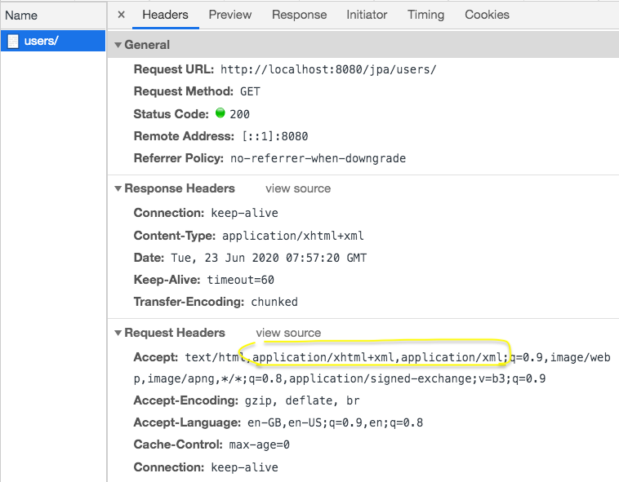

**Remove** this from **pom.xml**

1. <dependency>
2. <groupId>com.fasterxml.jackson.dataformat</groupId>
3. <artifactId>jackson-dataformat-xml</artifactId>
4. </dependency>

**WHY?**

**PROBLEM**: Browsers give preference to XML over JSON (They send Accept header with application/xml).

However, I prefer seeing responses with JSON in the browser (For most people REST = JSON)

COURSE UPDATE : USE SWAGGER 3.0.0 for Spring Boot 2.2+

If you are using Spring Boot Version >= 2.2, We recommend using SpringFox Swagger version 3.0.0.

**NEW URL for SWAGGER UI** - http://localhost:8080/swagger-ui/ or http://localhost:8080/swagger-ui/index.html

Example **pom.xml** with the changes here - <https://github.com/in28minutes/spring-microservices/blob/master/02.restful-web-services/2.3.1.RELEASE-upgrade.md#pomxml>

Example **SwaggerConfig** with the changes here - <https://github.com/in28minutes/spring-microservices/blob/master/02.restful-web-services/2.3.1.RELEASE-upgrade.md#srcmainjavacomin28minutesrestwebservicesrestfulwebservicesswaggerconfigjava>

Add these dependencies to pom.xml instead of the two swagger dependencies.

1. <dependency>
2. <groupId>io.springfox</groupId>
3. <artifactId>springfox-boot-starter</artifactId>
4. <version>3.0.0</version>
5. </dependency>

Configuring Auto Generation of Swagger

Open pom.xml and add swagger dependencies.

<dependency>

<groupId>io.springfox</groupId>

<artifactId>springfox-swagger2</artifactId>

<version>2.4.0</version>

</dependency>

<dependency>

<groupId>io.springfox</groupId>

<artifactId>springfox-swagger-ui</artifactId>

<version>2.4.0</version>

</dependency>

For Spring Boot >=2.2, use 3.0.0-SNAPSHOT

Create a class named SwaggerConfig and configure to use swagger 2

Add @Configuration and @EnableSwagger2 to configure swagger

@Configuration

@EnableSwagger2

public class SwaggerConfig{

@Bean

public Docket api(){

return new Docket(DocumentationType.SWAGGER_2);

}

}

//if you look at log..there are couple of new urls.

//Run localhost:8080/v2/api-docs

You will get a response of lot of documentation being generated

If you get an error, run it from REST Client or Remove Dependency Jackson-dataformat-xml from pom.xml

Go to localhost:8080/swagger-ui.html

You will get ui documentation of all your api’s

**Enhancing Swagger Documentation with Custom Annotations**

To add custom info in our services

@Configuration

@EnableSwagger2

public class SwaggerConfig{

public static final Contact DEFAULT_CONTACT = new Contact(“Ranga karanam”,

“http://www.in28minutes.com” , “[in28minutes@gmail.com](mailto:in28minutes@gmail.com)”);

public static final ApiInfo DEFAULT_API_INFO = new ApiInfo(“Awesome API Title”,

“Awesome API Description”,”1.0”,”urn:tos”, DEFAULT_CONTACT, “Apache 2.0”,

“<http://www.apache.org/licenses/LICENSE-2.0>”);

private static final Set<String> DEFAULT_PRODUCES_AND_CONSUMES =

new HashSet<String>(Arrays.asList(“application/json”,”application/xml”);

@Bean

public Docket api(){

return new Docket(DocumentationType.SWAGGER_2)

.apiInfo(DEFAULT_API_INFO)

.produces(DEFAULT_PRODUCES_AND_CONSUMES)

.consumes(DEFAULT_PRODUCES_AND_CONSUMES);

}

}

For Custom Info in User service documentation:

Use ApiModel annotation for custom info

**User.java**

@ApiModel(description= “All details about the user .”)

public class User{

private Integer id;

@Size(min=2,message=”Name should have atleast 2 characters”)

@ApiModelProperty(notes=”Name should have atleast 2 characters”)

private String name;

@Past

@ApiModelProperty(notes=”Birth date should be in the past”)

private Date birthdate;

protected User(){

}

public User(Integer id,String name,Date birthdate){

super();

**Monitoring APIs with Spring Boot Actuator**

If a service is failing, I want to know quickly as possible. It is very important to have great monitoring around your APIs and Spring Boot has great support to provide all this monitoring very easily. Add couple of dependencies.

* spring-boot-starter-actuator
* spring-data-rest-hal-browser

pom.xml

<dependency>

<groupId>org.springframework.boot</groupId>

<artifactId>spring-boot-starter-actuator</artifactId>

</dependency>

<dependency>

<groupId>org.springframework.data</groupId>

<artifactId>spring-data-rest-hal-browser</artifactId>

</dependency>

The HAL browser makes it easy to consume the HAL services which are being exposed by spring-boot-starter-actuator.

One of the important things to remember is that the actuator URLs have been changing quite a lot across Spring Boot releases. In Spring Boot 1.x, the URL was localhost:8080/actuator and later in the earlier versions of Spring 2.0.0,like the milestone releases, it was called localhost:8080/application . Now again, we are back to localhost:8080/actuator . So, this is the URL to launch up the actuator . I mean, this is after 2.0.0.release, the URL is localhost:8080/actuator. If it does not work, then probably you can give localhost:8080/application a try.

Launch : localhost:8080/actuator

You will see three urls:

* http://localhost:8080/actuator
* http://localhost:8080/actuator/health
* <http://localhost:8080/actuator/info>

If you launch health url, you will see health status i.e. {status: UP }. It means UP and running. And the other one is the info.There's not a lot of info here right now. There is a lot of stuff that actuator provides. To enable that, you'd need to configure a property.

Go to application.properties and type:

management.endpoints.web.exposure.include=*

Tip: Install Spring Tools Eclipse Plugin for recommendation.

Save and Restart your application.You will now see a many more URLs.If you will type localhost:8080 you will go to a hal browser. The auditevents is related to security.auditevents would show which users were properly validated,how many people failed the authentication, and all that kind of stuff. beans is another interesting thing. I am clicking beans. This would show all the Spring Beans that are configured right. Spring is a dependency management framework and it manages all the beans it creates, all the components for you, and you can look at all the beans that Spring has created for you. In future, if you need any such information, Use actuator. Note: Do not activate httptrace for production environment.

**Implementing Static Filtering for RESTful Service**

Hitting : http:/localhost:8080/users and getting response with birthdate parameter. We will filter response:Create new class FilteringController in package com.in28minutes.rest.webservices.restfulwebservices.filtering

Add @RestController annotation

Create new bean name Somebean.

@JsonIgnore annotation is used to ignore variable in response

@JsonIgnoreProperties is annotation written above public class Ex. @JsonIgnoreProperties(value={“field1”,”field2”}) //it will only response field3

**SomeBean.java**

package com.in28minutes.rest.webservices.restfulwebservices.filtering;

import com.fasterxml.jackson.annotation.JsonFilter;

@JsonIgnoreProperties(value={“field1”,”field2”})

public class SomeBean {

private String field1;

private String field2;

// @JsonIgnore

private String field3;

public SomeBean(String field1, String field2, String field3) {

super();

this.field1 = field1;

this.field2 = field2;

this.field3 = field3;

}

public String getField1() {

return field1;

}

public void setField1(String field1) {

this.field1 = field1;

}

public String getField2() {

return field2;

}

public void setField2(String field2) {

this.field2 = field2;

}

public String getField3() {

return field3;

}

public void setField3(String field3) {

this.field3 = field3;

} }

**FilteringController**

@RestController

public class FilteringController {

@GetMapping("/filtering")

public SomeBean retrieveSomeBean() {

return new SomeBean(“value1”,”value2”,”value3”);

}

@GetMapping("/filtering-list")

public List<SomeBean> retrieveListOfSomeBeans() {

return Arrays.asList(new SomeBean("value1", "value2", "value3"),

new SomeBean("value12", "value22", "value32"));

} }

**Implementing Dynamic Filtering for RESTful Service**

When you want to add specific values response in api

Add Annotation in SomeBean class - @JsonFilter("SomeBeanFilter")

package com.in28minutes.rest.webservices.restfulwebservices.filtering;

|  |
| --- |
|  |
|  |  |
|  | import java.util.Arrays; |
|  | import java.util.List; |
|  |  |
|  | import org.springframework.http.converter.json.MappingJacksonValue; |
|  | import org.springframework.web.bind.annotation.GetMapping; |
|  | import org.springframework.web.bind.annotation.RestController; |
|  |  |
|  | import com.fasterxml.jackson.databind.ser.FilterProvider; |
|  | import com.fasterxml.jackson.databind.ser.impl.SimpleBeanPropertyFilter; |
|  | import com.fasterxml.jackson.databind.ser.impl.SimpleFilterProvider; |
|  |  |
|  | @RestController |
|  | public class FilteringController { |
|  |  |
|  | // field1,field2 |
|  | @GetMapping("/filtering") |
|  | public MappingJacksonValue retrieveSomeBean() { |
|  | SomeBean someBean = new SomeBean("value1", "value2", "value3"); |
|  |  |
|  | SimpleBeanPropertyFilter filter = SimpleBeanPropertyFilter.filterOutAllExcept("field1", "field2"); |
|  |  |
|  | FilterProvider filters = new SimpleFilterProvider().addFilter("SomeBeanFilter", filter); |
|  |  |
|  | MappingJacksonValue mapping = new MappingJacksonValue(someBean); |
|  |  |
|  | mapping.setFilters(filters); |
|  |  |
|  | return mapping; |
|  | } |
|  |  |
|  | // field2, field3 |
|  | @GetMapping("/filtering-list") |
|  | public MappingJacksonValue retrieveListOfSomeBeans() { |
|  | List<SomeBean> list = Arrays.asList(new SomeBean("value1", "value2", "value3"), |
|  | new SomeBean("value12", "value22", "value32")); |
|  |  |
|  | SimpleBeanPropertyFilter filter = SimpleBeanPropertyFilter.filterOutAllExcept("field2", "field3"); |
|  |  |
|  | FilterProvider filters = new SimpleFilterProvider().addFilter("SomeBeanFilter", filter); |
|  |  |
|  | MappingJacksonValue mapping = new MappingJacksonValue(list); |
|  |  |
|  | mapping.setFilters(filters); |
|  |  |
|  | return mapping; |
|  | } |
|  |  |
|  | } |

SomeBean.java

package com.in28minutes.rest.webservices.restfulwebservices.filtering;

|  |
| --- |
|  |
|  |  |
|  | import com.fasterxml.jackson.annotation.JsonFilter; |
|  |  |
|  | @JsonFilter("SomeBeanFilter") |
|  | public class SomeBean { |
|  |  |
|  | private String field1; |
|  |  |
|  | private String field2; |
|  |  |
|  | private String field3; |
|  |  |
|  | public SomeBean(String field1, String field2, String field3) { |
|  | super(); |
|  | this.field1 = field1; |
|  | this.field2 = field2; |
|  | this.field3 = field3; |
|  | } |
|  |  |
|  | public String getField1() { |
|  | return field1; |
|  | } |
|  |  |
|  | public void setField1(String field1) { |
|  | this.field1 = field1; |
|  | } |
|  |  |
|  | public String getField2() { |
|  | return field2; |
|  | } |
|  |  |
|  | public void setField2(String field2) { |
|  | this.field2 = field2; |
|  | } |
|  |  |
|  | public String getField3() { |
|  | return field3; |
|  | } |
|  |  |
|  | public void setField3(String field3) { |
|  | this.field3 = field3; |
|  | } |
|  |  |
|  | } |

**Versioning RESTful Services – Basic Approach with URls**

Create a simple bean named Person and put into a package called versioning

We need variable name but we need separate firstName and lastName. So we will create two different class i.e. PersonV1 and PersonV2

public class PersonV1{

private String name;

}

public class PersonV2{

private Name name;

}

Generate Getters & Setters

Create class Name and declare firstName and lastName & generate getters and setters,constructor using fields,generate constructor with no arguments

package com.in28minutes.rest.webservices.restfulwebservices.versioning;

|  |  |
| --- | --- |
|  |  |
|  |  |
|  | public class Name { |
|  | private String firstName; |
|  | private String lastName; |
|  |  |
|  | public Name() { |
|  | } |
|  |  |
|  | public Name(String firstName, String lastName) { |
|  | super(); |
|  | this.firstName = firstName; |
|  | this.lastName = lastName; |
|  | } |
|  |  |
|  | public String getFirstName() { |
|  | return firstName; |
|  | } |
|  |  |
|  | public void setFirstName(String firstName) { |
|  | this.firstName = firstName; |
|  | } |
|  |  |
|  | public String getLastName() { |
|  | return lastName; |
|  | } |
|  |  |
|  | public void setLastName(String lastName) { |
|  | this.lastName = lastName; |
|  | } } |
|  |  |
|  |  |

Create class PersonVersioningController,Add @RestController annotation and create method personV1 & personV2:

@GetMapping(“v1/person”)

public PersonV1 personV1(){

return new PersonV1(“Bob Charlie”);

}

@GetMapping(“v2/person”)

public PersonV2 personV2(){

return new PersonV2(new Name(“Bob”, “Charlie”));

}

Execute <http://localhost:8080/v1/person> and <http://localhost:8080/v2/person> to see response

What we looked at until now is the basic way of doing versioning by actually mapping different URIs

In the next step, We'll also look at a few more ways of doing versioning.

And we would discuss what are the pros and cons for those approaches.

**Versioning RESTful Services – Header and Content Negotiation Approach**

In the previous step, we looked at versioning our APIs using our URI. In these step we will look different ways :

**Versioning Using Request Parameter**

Create two method named paramV1 and paramV2 :

@GetMapping(value=“ /person/param”,params=”version=1”)

public PersonV1 paramV1(){

return new PersonV1(“Bob Charlie”);

}

@GetMapping(value=“ /person/param”,params=”version=2”)

public PersonV2 paramV2(){

return new PersonV2(new Name(“Bob”, “Charlie”));

}

Execute <http://localhost:8080/person/param?version=1> and <http://localhost:8080/person/param?version=2> to see response.

**Header Versioning**

Create two method named headerV1 and headerV2 and take values in headers :

@GetMapping(value=“ /person/header”,headers=”X-API-VERSION=1”)

public PersonV1 headerV1(){

return new PersonV1(“Bob Charlie”);

}

@GetMapping(value=“ /person/header”, headers=” X-API-VERSION=2”)

public PersonV2 headerV2(){

return new PersonV2(new Name(“Bob”, “Charlie”));

}

Open Postman and execute url: <http://localhost:8080/person/header> and Add values in Headers i.e.

Key : X-API-VERSION , Value : 1

Response : { “name”: “Bob Charlie”}

Change Value to 2 to see other response.

Key : X-API-VERSION , Value : 2

Response :

{ “name”: {

“firstName”:“Bob”,

“lastName”: “Charlie”

} }

**Accept Header Versioning / Produces Versioning**

Create two method named producesV1 and producesV2 :

@GetMapping(value=“ /person/produces”, produces=”application/vnd.company.app-v1+json”)

public PersonV1 producesV1(){

return new PersonV1(“Bob Charlie”);

}

@GetMapping(value=“ /person/produces”, produces=”application/vnd.company.app-v2+json”))

public PersonV2 producesV2(){

return new PersonV2(new Name(“Bob”, “Charlie”));

}

Open Postman and execute url: <http://localhost:8080/person/produces> and Add values in Headers i.e

Key : Accept , Value : application/vnd.company.app-v1+json

Response : { “name”: “Bob Charlie” }

Change Value to application/vnd.company.app-v2+json to see other response.

**#### Versioning**

* Media type versioning (a.k.a “content negotiation” or “accept header”)
  + Github
* (Custom) headers versioning
  + Microsoft
* URI Versioning
  + Twitter
* Request Parameter versioning
  + Amazon
* Factors
  + URI Pollution
  + Misuse of HTTP Headers
  + Caching
  + Can we execute the request on browser? Nope for Media type & headers versioning. User will need any plugin like postman.
  + API Documentation
* No Perfect Solution

Before you build your first API, have your versioning strategy really. Build a few examples of it, test them, make sure they are all working for your needs.

**Implementing Basic Authentication with Spring Security**

Open pom.xml and add spring boot starter security dependency

**pom.xml**

<dependency>

<groupId>org.springframework.boot</groupId>

<artifactId>spring-boot-starter-security</ artifactId >  
</dependency>

When you restart server you will see default security password in log (‘Using default security password : encoded password’).

When you will fire localhost8080/users or any url it will fire an error saying unauthorized.

Add Authorization and type : Basic Auth

Add Username : user and Password : encoded password to see 200 response.

To change default username and password :

Go to application.properties and add :

security.user.name=username

security.user.password=password

**COURSE UPDATE : H2 Database URL**

With the latest versions of Spring Boot (2.3+), the H2 database name is randomly generated each time you restart the server.You can find the database name and URL from the console log.

**RECOMMENDED**: Make the database URL a constant by configuring this in application.properties.

1. spring.datasource.url=jdbc:h2:mem:testdb
2. spring.data.jpa.repositories.bootstrap-mode=default

**DEBUGGING GUIDE (If you have problems)**

JPA Hibernate Debugging Guide: <https://github.com/in28minutes/in28minutes-initiatives/blob/master/The-in28Minutes-TroubleshootingGuide-And-FAQ/jpa-and-hibernate.md>

Why do we need to configure bootstrap-mode? Details here - <https://github.com/spring-projects/spring-boot/wiki/Spring-Boot-2.3-Release-Notes#bootstrapmode-for-jpa-repositories>

So we will have a new thing called user repository which is created which would be the one which would be talking to the database and we would step by step convert the user source to use JPA instead of the hardcoded arraylist.

**Creating user entity and some test data**

Add two dependency i.e. starter-data-jpa and h2-database

<dependency>

<groupId>org.springframework.boot</groupId>

<artifactId>spring-boot-starter-data-jpa</artifactId>

</dependency>

<dependency>

<groupId>com.h2database</groupId>

<artifactId>h2</artifactId>

<scope>runtime</scope>

</dependency>

Add @Entity annotation in entity i.e. User.java

Add @Id and @GeneratedValue in Integer id;

**User.java**

@Entity

public class User{

@Id

@GeneratedValue

private Integer id;

**Disable Security -- Comment spring starter dependency in pom.xml**

Go to application.properties for enable h2 console

//for logging database query

spring.jpa.show-sql=true

spring.h2.console.enabled=true

if you will restart your app you would see fired query in your log like ‘Hibernate: drop table if exists’ etc.

Executed query:

create table user(

id integer not null,

birth_date timestamp,

name varchar(255).

primary key (id)

)

To put some data in user table:

We will create sql file in src/main/resources named data.sql(next and finish)

Write query in data.sql: //you cannot use double quote

insert into user values(1,sysdate(),’AB’);

insert into user values(2,sysdate(),’Jill’);

insert into user values(3,sysdate(),’Jam’);

Restart server and go to h2-console (localhost:8080/h2-console)

Verify that JDBC URL has value jdbc:h2:mem:testdb

Saved Settings: Generic H2 Embedded) and connect

Go to sql statement and execute “select * from user to see user”

So, all the users which we have inserted is now present in the table. In the next step,what we'd focus on is updating our resources to get the data from here.

So, let's pick up the simplest of the resources, which is /users, get retrieve all users.What we'll do is, we'll try and update that to use the data from the database.

Right now we have the user resource which is actually talking to the in-memory list. We would want to make it talk to the embedded database.

We will create service to retrieve all users.

Copy UserResource.java and paste and name UserJPAResource.java

Convert dao service(static arraylist to jpa)

Mappings are getting clash. Add ‘/jpa’ in all UserJPAResource mapping

**UserJPAResource.java**

@GetMapping(“/users”) to @GetMapping(“/jpa/users”)

@GetMapping(“/users”) to @GetMapping(“/jpa/users/{id}”)

@DeleteMapping(“/users/{id}”) to @DeleteMapping(“/jpa/users/{id}”)

**Updating GET methods on User Resource to use JPA**

Create a new interface named UserRepositoy

Add Annotation @Repository.

Import JpaRepository and Extends JpaRepository<User,Integer> //JpaRepository<Entity,PrimaryKey>

Declare UserRepository in UserJPAResource and add Autowired annotation

Change retrieveAllUsers method: in UserJPAResource

-return userRepository.findAll();

Go to postman and request GET – <http://localhost:8080/jpa/users>

Response: (this data is coming from embedded database)

{

{

“id”:1,

“name”:”AB”,

“birthdate”: “2017-07-20”

},

{

“id”:2,

“name”:”Jill”,

“birthdate”: “2017-07-20”

}

}

Change /jpa/users/{id} retrieveUser method

Change service to userrepository.(findById return optional for check is present or not.

**UserJPAResource.java**

@GetMapping(“/jpa/users/{id}”)

public Resource<User> retrieveUser(@PathVariable int id){

Optional<User> user = userRepository.findById(id);

If(!user.isPresent()){

throw new UserNotFoundException(“id-“+id);

}

//”all-users”,SERVER_PATH = “/users”

//retrieveAllUsers

Resource<User> resource = new Resource<User>(user.get());

ControllerLinkBuilder linkTo =

linkTo(methodOn(this.getClass()).retrieveAllUsers());

resource.add(linkTo.withRel(“all-users”));

//HATEOS

return resource;

}

Fire request: <http://localhost:8080/jpa/users/1> in postman and you will get response : 200 OK

{

“name” : ”AB”,

“birthDate” : “2017-07-20T12:00:21.769+0000”,

“_links”:{

“all-users”: {

“href”: “http://localhost:8080/jpa/users”

}

}

}

**Updating POST and DELETE methods on User Resource to use JPA**

Update deleteUser method

@DeleteMapping(“/jpa/users/{id}”)

userRepository.deleteById(id);

}

Update createUser method - Change service.save(user) to userRepository.save(user)

@PostMapping(“/jpa/users”)

public ResponseEntity<Object> createUser(@Valid @RequestBody User user){

User savedUser = userRepository.save(user);

URI location = ServletUriComponentsBuilder .fromCurrentRequest().path(“/{id}”) .buildAndExpand(savedUser.getId()).toUri();

return ResponseEntity.created(location).build();

}

When you will try to create a user with same id..you will get an error : ConstraintViolationException because of db sequence

Go to data.sql and change queries id(1,2,3) to (10001,10002,10003)

Fire POST-http://localhost:8080/jpa/users and response status will be 201 created, go to h2-console and check table if it is created or not.

Remove declaration : UserDaoService service,

**Creating Post Entity and Many to One Relationship with User Entity**

Create a new class called Post. Add @Entity annotation and declare Integer id,String description, User user. Create getters and setters and toString(should not select user because user will print post..and we will be out of memory)

#Do not print details of the user

So this post entity and there is a user entity.

What is the relationship between this? A user entity can do many posts.

So a post is tied back to one user, right? So the relationship is many to one.

Add @ManytoOne(fetch=FetchType.LAZY) annotation on private User user and fetch as lazy, This will not retrieve the details of the user unless you call post.getUser()

Add @Id and @GeneratedValue at Integer id to make is this the primary key

Configure Relationship in User side –

So a user can make a list of post.So a post has a one to many relationship.

Add private List<Post> posts; and add annotation @OneToMany(mappedBy=”user”)

So, I am saying mapped by, which is the field which is owning the relationship. I don't want to create the relationship column in both user and post. I would actually just create the relationship column of user in post. So I'm saying it's mapped by is equal to the name of the field in post. The name of the field in post is user.

Create getters and setters(above toString) for posts in User.java

Restart application and see log.

**Post.java**

package com.in28minutes.rest.webservices.restfulwebservices.user;

|  |
| --- |
|  |
|  |  |
|  | import javax.persistence.Entity; |
|  | import javax.persistence.FetchType; |
|  | import javax.persistence.GeneratedValue; |
|  | import javax.persistence.Id; |
|  | import javax.persistence.ManyToOne; |
|  |  |
|  | import com.fasterxml.jackson.annotation.JsonIgnore; |
|  |  |
|  | @Entity |
|  | public class Post { |
|  |  |
|  | @Id |
|  | @GeneratedValue |
|  | private Integer id; |
|  | private String description; |
|  |  |
|  | @ManyToOne(fetch=FetchType.LAZY) |
|  | @JsonIgnore |
|  | private User user; |
|  |  |
|  | public Integer getId() { |
|  | return id; |
|  | } |
|  |  |
|  | public void setId(Integer id) { |
|  | this.id = id; |
|  | } |
|  |  |
|  | public String getDescription() { |
|  | return description; |
|  | } |
|  |  |
|  | public void setDescription(String description) { |
|  | this.description = description; |
|  | } |
|  |  |
|  | public User getUser() { |
|  | return user; |
|  | } |
|  |  |
|  | public void setUser(User user) { |
|  | this.user = user; |
|  | } |
|  |  |
|  | @Override |
|  | public String toString() { |
|  | return String.format("Post [id=%s, description=%s]", id, description); |
|  | } |
|  |  |
|  | } |

**User.java**

package com.in28minutes.rest.webservices.restfulwebservices.user;

|  |
| --- |
|  |
|  |  |
|  | import java.util.Date; |
|  | import java.util.List; |
|  |  |
|  | import javax.persistence.Entity; |
|  | import javax.persistence.GeneratedValue; |
|  | import javax.persistence.Id; |
|  | import javax.persistence.OneToMany; |
|  | import javax.validation.constraints.Past; |
|  | import javax.validation.constraints.Size; |
|  |  |
|  | import io.swagger.annotations.ApiModel; |
|  | import io.swagger.annotations.ApiModelProperty; |
|  |  |
|  | @ApiModel(description="All details about the user.") |
|  | @Entity |
|  | public class User { |
|  |  |
|  | @Id |
|  | @GeneratedValue |
|  | private Integer id; |
|  |  |
|  | @Size(min=2, message="Name should have atleast 2 characters") |
|  | @ApiModelProperty(notes="Name should have atleast 2 characters") |
|  | private String name; |
|  |  |
|  | @Past |
|  | @ApiModelProperty(notes="Birth date should be in the past") |
|  | private Date birthDate; |
|  |  |
|  | @OneToMany(mappedBy="user") |
|  | private List<Post> posts; |
|  |  |
|  | protected User() { |
|  |  |
|  | } |
|  |  |
|  | public User(Integer id, String name, Date birthDate) { |
|  | super(); |
|  | this.id = id; |
|  | this.name = name; |
|  | this.birthDate = birthDate; |
|  | } |
|  |  |
|  | public Integer getId() { |
|  | return id; |
|  | } |
|  |  |
|  | public void setId(Integer id) { |
|  | this.id = id; |
|  | } |
|  |  |
|  | public String getName() { |
|  | return name; |
|  | } |
|  |  |
|  | public void setName(String name) { |
|  | this.name = name; |
|  | } |
|  |  |
|  | public Date getBirthDate() { |
|  | return birthDate; |
|  | } |
|  |  |
|  | public void setBirthDate(Date birthDate) { |
|  | this.birthDate = birthDate; |
|  | } |
|  |  |
|  | public List<Post> getPosts() { |
|  | return posts; |
|  | } |
|  |  |
|  | public void setPosts(List<Post> posts) { |
|  | this.posts = posts; |
|  | } |
|  |  |
|  | @Override |
|  | public String toString() { |
|  | return String.format("User [id=%s, name=%s, birthDate=%s]", id, name, birthDate); |
|  | } |
|  |  |
|  | } |

When you look at the log, you would see that there are two tables. There is create table post. It has an Id and also it would have a foreign key. It’s called user Id integer.

So the post table has a link to the user table by a user Id. A user can have multiple posts and all of them would have the same user Id against it.

If you go and refresh h2-console,you would able to see tables i.e. post table with id,description,user_id and user table with id,birth_date,name

Open data.sql and create couple of posts and insert in database

insert into post values(11001,’My First Post’,10001);

insert into post values(11002,’My Second Post’,10001);

Launch Application and you will see data in post table.

In next steps, we will retreive this data using RESTful services.

**Implementing a GET service to retrieve all Posts of a User**

Add @JsonIgnore on private User user to avoid recursive loop

Write a service to retrieve all posts named retrieveAllUsers method in UserJPAResource to retrieve posts by id

**UserJPAResource.java**

package com.in28minutes.rest.webservices.restfulwebservices.user;

|  |
| --- |
|  |
|  |  |
|  | import static org.springframework.hateoas.server.mvc.WebMvcLinkBuilder.linkTo; |
|  | import static org.springframework.hateoas.server.mvc.WebMvcLinkBuilder.methodOn; |
|  |  |
|  | import java.net.URI; |
|  | import java.util.List; |
|  | import java.util.Optional; |
|  |  |
|  | import javax.validation.Valid; |
|  |  |
|  | import org.springframework.beans.factory.annotation.Autowired; |
|  | import org.springframework.hateoas.EntityModel; |
|  | import org.springframework.hateoas.server.mvc.WebMvcLinkBuilder; |
|  | import org.springframework.http.ResponseEntity; |
|  | import org.springframework.web.bind.annotation.DeleteMapping; |
|  | import org.springframework.web.bind.annotation.GetMapping; |
|  | import org.springframework.web.bind.annotation.PathVariable; |
|  | import org.springframework.web.bind.annotation.PostMapping; |
|  | import org.springframework.web.bind.annotation.RequestBody; |
|  | import org.springframework.web.bind.annotation.RestController; |
|  | import org.springframework.web.servlet.support.ServletUriComponentsBuilder; |
|  |  |
|  | @RestController |
|  | public class UserJPAResource { |
|  |  |
|  | @Autowired |
|  | private UserRepository userRepository; |
|  |  |
|  | @Autowired |
|  | private PostRepository postRepository; |
|  |  |
|  | @GetMapping("/jpa/users") |
|  | public List<User> retrieveAllUsers() { |
|  | return userRepository.findAll(); |
|  | } |
|  |  |
|  | @GetMapping("/jpa/users/{id}") |
|  | public EntityModel<User> retrieveUser(@PathVariable int id) { |
|  | Optional<User> user = userRepository.findById(id); |
|  |  |
|  | if (!user.isPresent()) |
|  | throw new UserNotFoundException("id-" + id); |
|  |  |
|  | // "all-users", SERVER_PATH + "/users" |
|  | // retrieveAllUsers |
|  | EntityModel<User> resource = EntityModel.of(user.get());//new EntityModel<User>(user.get()); |
|  |  |
|  | WebMvcLinkBuilder linkTo = linkTo(methodOn(this.getClass()).retrieveAllUsers()); |
|  |  |
|  | resource.add(linkTo.withRel("all-users")); |
|  |  |
|  | // HATEOAS |
|  |  |
|  | return resource; |
|  | } |
|  |  |
|  | @DeleteMapping("/jpa/users/{id}") |
|  | public void deleteUser(@PathVariable int id) { |
|  | userRepository.deleteById(id); |
|  | } |
|  |  |
|  | // |
|  | // input - details of user |
|  | // output - CREATED & Return the created URI |
|  |  |
|  | // HATEOAS |
|  |  |
|  | @PostMapping("/jpa/users") |
|  | public ResponseEntity<Object> createUser(@Valid @RequestBody User user) { |
|  | User savedUser = userRepository.save(user); |
|  |  |
|  | URI location = ServletUriComponentsBuilder.fromCurrentRequest().path("/{id}").buildAndExpand(savedUser.getId()) |
|  | .toUri(); |
|  |  |
|  | return ResponseEntity.created(location).build(); |
|  |  |
|  | } |
|  |  |
|  | @GetMapping("/jpa/users/{id}/posts") |
|  | public List<Post> retrieveAllUsers(@PathVariable int id) { |
|  | Optional<User> userOptional = userRepository.findById(id); |
|  |  |
|  | if(!userOptional.isPresent()) { |
|  | throw new UserNotFoundException("id-" + id); |
|  | } |
|  |  |
|  | return userOptional.get().getPosts(); |
|  | } |
|  |  |
|  |  |
|  | @PostMapping("/jpa/users/{id}/posts") |
|  | public ResponseEntity<Object> createPost(@PathVariable int id, @RequestBody Post post) { |
|  |  |
|  | Optional<User> userOptional = userRepository.findById(id); |
|  |  |
|  | if(!userOptional.isPresent()) { |
|  | throw new UserNotFoundException("id-" + id); |
|  | } |
|  |  |
|  | User user = userOptional.get(); |
|  |  |
|  | post.setUser(user); |
|  |  |
|  | postRepository.save(post); |
|  |  |
|  | URI location = ServletUriComponentsBuilder.fromCurrentRequest().path("/{id}").buildAndExpand(post.getId()) |
|  | .toUri(); |
|  |  |
|  | return ResponseEntity.created(location).build(); |
|  |  |
|  | } |
|  |  |
|  | } |

Fire request GET – <http://localhost:8080/jpa/users/10001/posts>

Response:

[ {

“id”: 11001,

“description”: ”My First Post”

},{

“id”: 11002,

“description”: ”My Second Post”

}

]

Create interface PostRepository extends JpaRepository<Post ,Integer>

Declare PostRepository in UserJPAResource.java

Create method to create post:

|  |
| --- |
| @PostMapping("/jpa/users/{id}/posts") |
| public ResponseEntity<Object> createPost(@PathVariable int id, @RequestBody Post post) { |
|  |
| Optional<User> userOptional = userRepository.findById(id); |
|  |
| if(!userOptional.isPresent()) { |
| throw new UserNotFoundException("id-" + id); |
| } |
|  |
| User user = userOptional.get(); |
|  |
| post.setUser(user); |
|  |
| postRepository.save(post); |
|  |
| URI location = ServletUriComponentsBuilder.fromCurrentRequest().path("/{id}").buildAndExpand(post.getId()) |
| .toUri(); |
|  |
| return ResponseEntity.created(location).build(); |
|  |
| } |

Go to postman and hit POST- <http://localhost:8080/jpa/users/10001/posts>

In the body, select raw and add

{

“description”: “My Third Post”

}

Response : 201 Created.

Go to database and check in post table it is created or not.

**RICHARDSON MATURITY MODEL**

LEVEL 0 – EXPOSE SOAP WEB SERVICES IN REST STYLE

* <http://server/getPosts>
* <http://server/deletePosts>
* <http://server/doThis>

LEVEL 1 – EXPOSE RESOURCES WITH PROPER URL

NOTE: IMPROPER USE OF HTTP METHODS

* <http://server/accounts>
* <http://server/accounts/10>

LEVEL 2 – LEVEL 1 + HTTP METHODS (We used)

LEVEL 3 – LEVEL 2 + HATEOS DATA + NEXT POSSIBLE ACTIONS (not just data but also next possible actions (hyperlink))

**RESTful Web Services – Best Practices**

CONSUMER FIRST-

Swagger is one of the most popular documentation standards for RESTful APIs. But whatever standard you are using,Make sure that your consumers understand the documentation that you produce. The next important best practice.

Make the best use of whatever HTTP provides. RESTful web services are based on HTTP. Make the best use of the request methods.

Use the right request method appropriate for your specific action:

* Get
* Post
* Put
* Delete

And ensure that you're sending a proper response status back. When a resource is not found.

When there is a bad request, when there is a validation error, do not send the server error. Send a bad request 400.

When you create a resource do not send just success. Send created back.

**RESPONSE STATUS**

* 200 - SUCCESS
* 404 - RESOURCE NOT FOUND
* 400 - BAD REQUEST
* 201 - CREATED
* 401 - UNAUTHORIZED
* 500 - SERVER ERROR

NO SECURE INFO IN URI

Think about what you're putting in the URI and make sure that there is nothing secure that going in your URIs. Always use plurals.

For example, in the course, we always used slash users. Any resource that we created was user/1. Not /user/1.

**USE PLURALS**

* Prefer /users to /user
* Prefer /users/1 to /user/1

**USE NOUNS FOR RESOURCES**

I really prefer using the plurals because it’s more readable than using the singular. When you think resources think noun’s.

**FOR EXCEPTIONS**

**DEFINE A CONSISTENT APPROACH**

* /search
* PUT /GISTS/{id}/star
* DELETE /GISTS/{id}/star

**Microservices with Spring Cloud**

Go to github.com and search for in28minutes/spring-microservices

03. microservices for microservices documentation(Index and different ports,urls and complete code available here)

**INDEX**

1. Spring Cloud Config Server and Bus

2. Load Balancing with Ribbon and Feign

3. Implement Naming Server with Eureka

4. Implementing API Gateway with Zuul

5. Distributed Tracing with Zipkin

6. Fault Tolerance with Hystrix

**MICROSERVICES**

* REST
* & Small Well Chosen Deployable Units
* & Cloud Enabled

The important parts are REST having small deployable units which can be cloud enabled.

**HOW DOES IT LOOK?**

**SERVICES INSTANCES**

A2

A1

Microservice1

B4

B3

B2

B1

Microservice2

C1

Microservice3

**Challenges with Microservices**

* Configuration Management
* DYNAMIC SCALE UP AND DOWN

How do we simplify say that we would want to be able to dynamically scale up and scale down and dynamically distribute load among the active instances.

How do we do that.We want to have great visibility into what's happening behind the scenes with each of these microservices.A simple request might involve 10 microservices how do I determine which microservice was caused for a defect. How do I know if all my microservices are up and running.

And how do I prevent one microservice being down taking down the entire application.

**Introduction to Spring Cloud**

The umbrella of spring cloud which help us to provide solutions to the challenges we discussed. If you go to the home page of spring cloud which is cloud.spring.io it says spring cloud provides tools to quickly build some of the common patterns in distributed systems to the typical problems which are present for distributed systems in the cloud spring cloud provides a range of solutions. One of the important projects in spring cloud is spring cloud Netflix. Netflix was one of the organizations which started playing around with the microservices architecture very early. Eureka Hystrix , Zuul and so on other than spring cloud Netflix.

There are a wide range of projects under the umbrella of spring cloud.

Some of them are spring cloud config which is to provide a centralized configuration management spring cloud bus.

This enables the microservices and the infrastructure components things like config server things like API gateway to talk to each other in this course we'd be using the Finchley M2.

One of the challenges we talked about earlier was configuration management.

We talked about the fact that there would be multiple microservices multiple environments for each of these microservices and multiple instances in many of those environments.

This would mean that there is a lot of configuration for these microservices that the operations team needs to manage.

Spring cloud config server provides an approach where you can store all configuration for all the different environment of all the microservices in a Git repository.

So you can store all the configuration for different environments of different microservices in just one place in a centralized location and spring cloud config server can be used to expose that configuration to all the microservices.

This helps us to keep the configuration in one place and that makes it very easy to maintain the configuration for all the MicroServices.

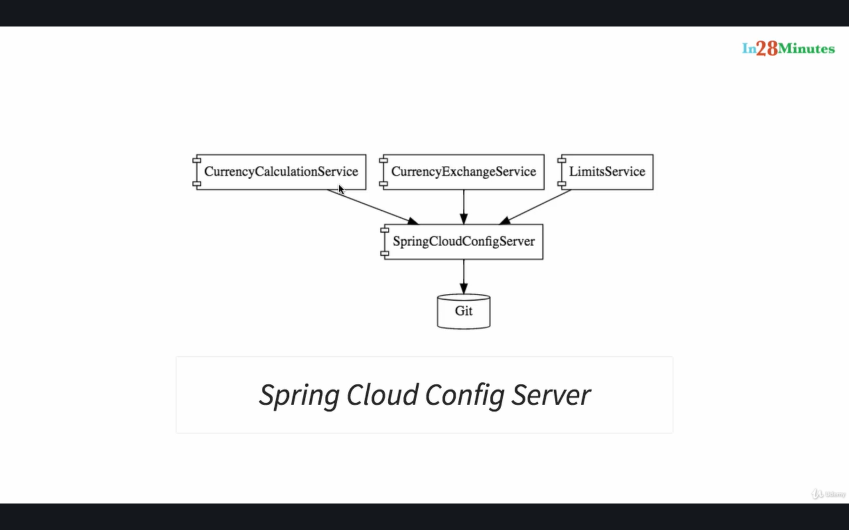

**DYNAMIC SCALE UP AND DOWN**

* Naming Server (Eureka)
* Ribbon (Client Side Load Balancing)
* Feign (Easier REST Clients)

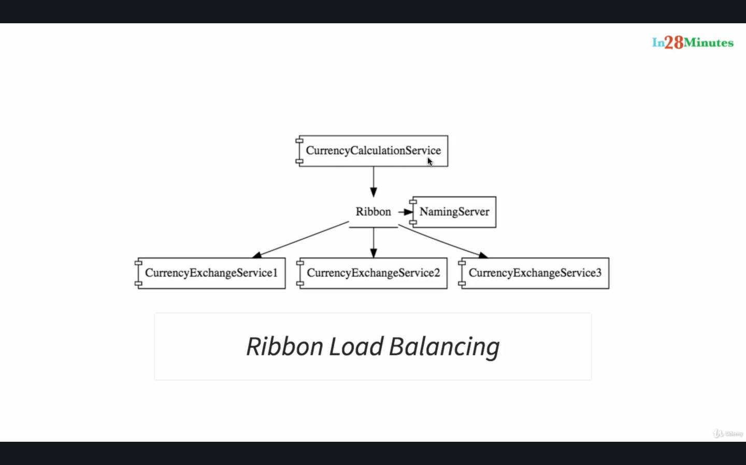

In the example you are looking at there is MicroService is called currency calculation service which is talking to the currency exchange service. As you can see in the diagram there are multiple instances of the currency exchange service and it's possible that at any point in time new instances can be added in or removed out. And we would want the currency calculations that we'd want to be able to distribute the load between all the instances of the currency exchange service. Who would want to be able to dynamically check what are the available instances of the currency exchange service and make sure that the load is distributed among all of them.

The solution which we would be discussing in this course would be using a naming server which is Eureka. So all the instances of all MicroServices would register with the naming server.

So the naming server has two important features.One is service registration so all microservices. Can register with the microservice one the second one is service discovery.

So in this example the currency calculation service can ask the Eureka naming server Hey naming server give me the current instances of currency exchange service and the naming service would provide those URLs to the currency calculations. This helps to establish dynamic relationship between the currency calculation service and the instances of the currency exchange service.

We will use Ribbon for client side load balancing. That means the currency calculation service will host ribbon and it would make sure that the load is

evenly distributed among the existing instances that it gets from the naming server we'll also use Feign in the currency calculation service as a mechanism to write simple RESTful clients.

**VISIBLITY AND MONITORING**

* Zipkin Distributed Tracing
* Netflix API Gateway

The solutions for visibility and monitoring are the zipkin distributing Tracing Server.We would use Spring cloud Sloat to assign ID to request across multiple components and we would use the Zipkin distributed tracing to trace a request across multiple components.

One of the important things about microservices is these microservices have a lot of common features.For example logging security analytics and things like that you don't want to implement all these common features in every microservice. API Gateways provide great solutions to these kind of challenges.We will use a Netflix Zuel API gateway in this could.

**FAULT TOLERANCE**

* Hystrix

We will also implement fault tolerance using hystrix if a service is down. Hystrix help us to configure a default response in this video.

**Microservice Components – Standardizing Ports and URL**

We would be installing at least seven different projects and therefore it's very important to standardize the ports on which we would run these applications.

Go to github repository under in28minutes/spring-microservices/03.microservices/

Scroll further down for list of Ports & URLs.

**Ports**

|  |  |
| --- | --- |
| **Application** | **Port** |
| Limits Service | 8080, 8081, ... |
| Spring Cloud Config Server | 8888 |
|  |  |
| Currency Exchange Service | 8000, 8001, 8002, .. |
| Currency Conversion Service | 8100, 8101, 8102, ... |
| Netflix Eureka Naming Server | 8761 |
| Netflix Zuul API Gateway Server | 8765 |
| Zipkin Distributed Tracing Server | 9411 |

**URLs**

|  |  |
| --- | --- |
| **Application** | **URL** |
| Limits Service | <http://localhost:8080/limits> <http://localhost:8080/actuator/refresh> (POST) |
| Spring Cloud Config Server | <http://localhost:8888/limits-service/default> <http://localhost:8888/limits-service/dev> |
| Currency Converter Service - Direct Call | <http://localhost:8100/currency-converter/from/USD/to/INR/quantity/10> |
| Currency Converter Service - Feign | <http://localhost:8100/currency-converter-feign/from/EUR/to/INR/quantity/10000> |
| Currency Exchange Service | <http://localhost:8000/currency-exchange/from/EUR/to/INR> <http://localhost:8001/currency-exchange/from/USD/to/INR> |
| Eureka | <http://localhost:8761/> |
| Zuul - Currency Exchange & Exchange Services | <http://localhost:8765/currency-exchange-service/currency-exchange/from/EUR/to/INR> <http://localhost:8765/currency-conversion-service/currency-converter-feign/from/USD/to/INR/quantity/10> |
| Zipkin | <http://localhost:9411/zipkin/> |
| Spring Cloud Bus Refresh | <http://localhost:8080/actuator/bus-refresh> (POST) |

If you want to use latest version – Skip Version 1

Learn V1 if you are working on Lower Version (Spring Boot v2.3 and LOWER)

**Section 6 – Microservices with Spring Cloud – V2**

* **Latest Versions of Spring Boot and Spring Cloud:** 
  + Spring Cloud Load Balancer instead of Ribbon.
  + Spring Cloud Gateway instead of Zuul.
  + Resilience4j instead of Hystrix.
* **Docker**: Containerize Microservices
  + Run microservices using Docker and Docker Compose
* **Kubernetes:** Orchestrate all your Microservices with Kubernetes

Download Course From Here :

<https://github.com/in28minutes/course-material/blob/main/01-spring-microservices/v2/downloads.md>

**Setting up Limits Microservice**

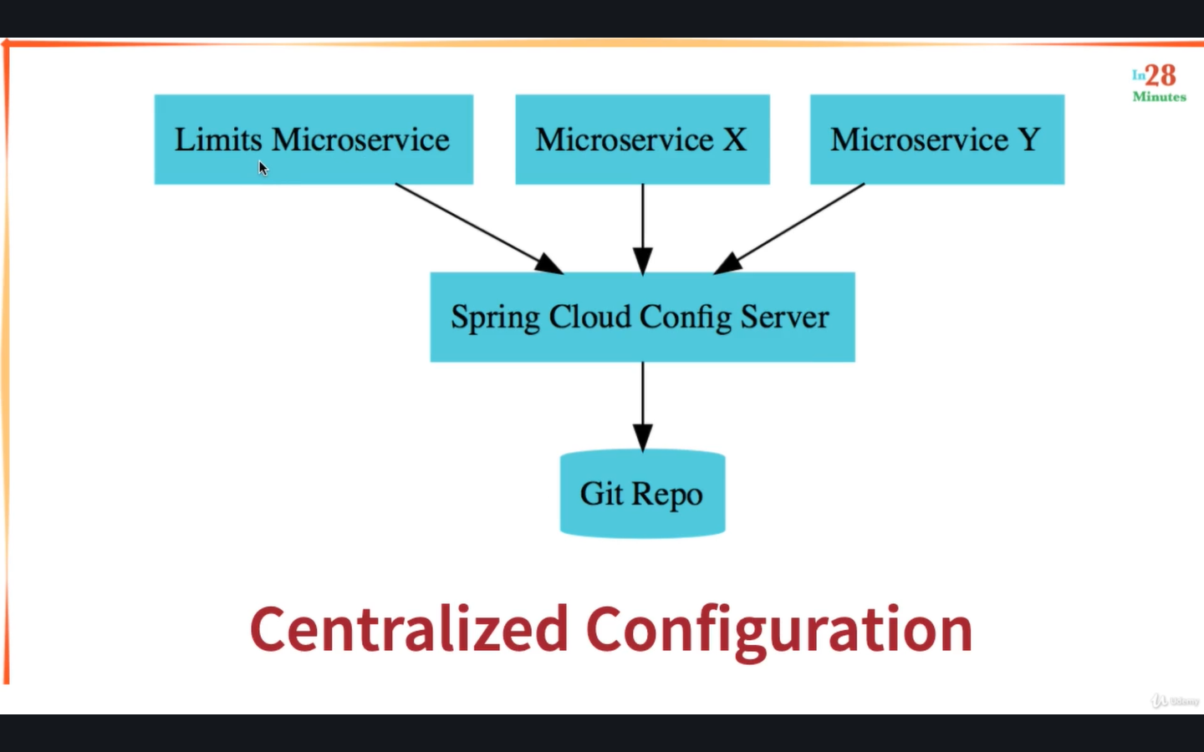

We create Limits microservice, and then we'll set up a spring cloud config server, which would be connected to a good repository.

To create Microservice , Go to start.spring.io

Create a project (select maven project) and Choose any latest release version

How do you identify released versions?These released versions do not have any suffixed. They don't have M-2 or Snapshot or anything attached with that.

So the latest release version I see right now is 2.4.1.

Enter groupId: com.in28minutes.microservices,artifact: limits-service , name: limits-service, description: Demo project for spring boot Centralized Configuration

Click Add Dependencies-🡪 Select:

* spring web 🡪 for rest api
* Spring boot devtools 🡪 fast application restart,live reload
* Spring boot actuator 🡪monitoring and managing application
* Spring cloud Config client 🡪client that connects to a spring cloud config server to fetch the application

Generate Project (it will create and download zip )

Unzip and copy the folder and open sts & Import as Maven Project

Go to file, Import 🡪type maven and choose existing maven projects,choose project🡪limits-service.(you will see pom.xml)see no space root directory

First Time it may take a long time. Take a break and import completely project.

If you have any problems with the import, I would recommend you to make sure that you have the latest version of Eclipse for enterprise developers installed.

Open pom.xml, you will see four dependency which you selected on spring.io

Launch Application and see if it runs fine .We have to create simple rest controller. We will start with hardcoded rest api returning data first.

Create new class in com.in28minutes.microservices.limitservice.controller package named LimitsController

Add Annotation @RestController

Create method retrieveLimits() which return Limits and Add mapping @GetMapping(“/limits”) and organize imports..

Create class Limits in package limitservice.bean and declare private int minimum, private int maximum and generate getters and setters and generate constructor and also no args constructor

Go to limits controller and return new Limits(1,1000);

Hit localhost:8080/limits : you will see {“minimum”:1,”maximum”:1000}

**LimitsController**

@RestController

public class LimitsController{

@GetMapping(“/limits”)

public Limits retrieveLimits(){

return new Limits(1,1000);

}

}

**Limits.java**

package com.in28minutes.microservices.limitsservice.bean;

public class Limits {

private int minimum;

private int maximum;

public Limits() {

super();

}

public Limits(int minimum, int maximum) {

super();

this.minimum = minimum;

this.maximum = maximum;

}

public int getMinimum() {

return minimum;

}

public void setMinimum(int minimum) {

this.minimum = minimum;

}

public int getMaximum() {

return maximum;

}

public void setMaximum(int maximum) {

this.maximum = maximum;

}

}

**Enhance limits service – Get configuration from application props**

Open application.properties and declare:

limits-service.minimum = 2

limits-service.maximum = 998

Create new class named Configuration in com.in28minutes.microservices.limitservice.configuration

Declare private int minimum, private int maximum

Add Annotation @Component

Add Annotation @ConfigurationProperties(“limits-service”) to get data from application.properties --- limits-service.minimum , limits-service.maximum will get mapped

Generate getters and setters in Configuration for minimum & maximum

Go to LimitsController

Add private Configuration configuration and add @Autowired

Return configuration in retrieveLimits() method:

return new Limits(configuration.getMinimum(),configuration.getMaximum());

**Setting up Spring Cloud Config Server**

Go to start.spring.io

Add Artifact : spring-cloud-config-server , Name: spring-cloud-config-server ,

Description : Centralized Configuration Server , Package name : com.in28minutes.microservices.spring-cloud-config-server

Add Dependencies : Spring Boot DevTools , Config Server

Generate and Download Project & extract and import

File 🡪 Import 🡪 Existing Maven Projects 🡪 Browse & select project and finish

Open pom.xml & check config-server & dev-tools

You will not able to launch because port is already in use

Go to application.properties and add

spring.application.name =spring-cloud-config-server

server.port = 8888

Launch Application

**Installing Git and Creating Local Git Repository**

Go to git-scm.com to download git

Go to downloads & download & install git based on your OS

Download Pro Git book to learn git commands

Open cmd/terminal and command git –version to check if it is installed

Present folder is 03.microservices.Create anywhere you want. Make sure that you don’t left any space

mkdir git-localconfig-repo

cd git-localconfig-repo/ (Use echo %cd% on Windows)

pwd command to go /in28minutes/git/spring-microservices-v2/03.microservices/git-localconfig-rangaraokaranam

**cd and git init** to create git repository(It will initialize empty git repository in specific folder)

open up any text editor and go over to that specific folder.

We would want to store all our configuration files in here in this git local config repo so you can and open Visual Studio Code.

Open project-🡪 git localconfig-repo in visual studio..

Create new file limits-service.properties and add values

limits-service.minimum = 4

limits-service.maximum = 996

Go to cmd and ls to see file and command

git add *

git commit –m “adding limits-service.properties”

It will get commited

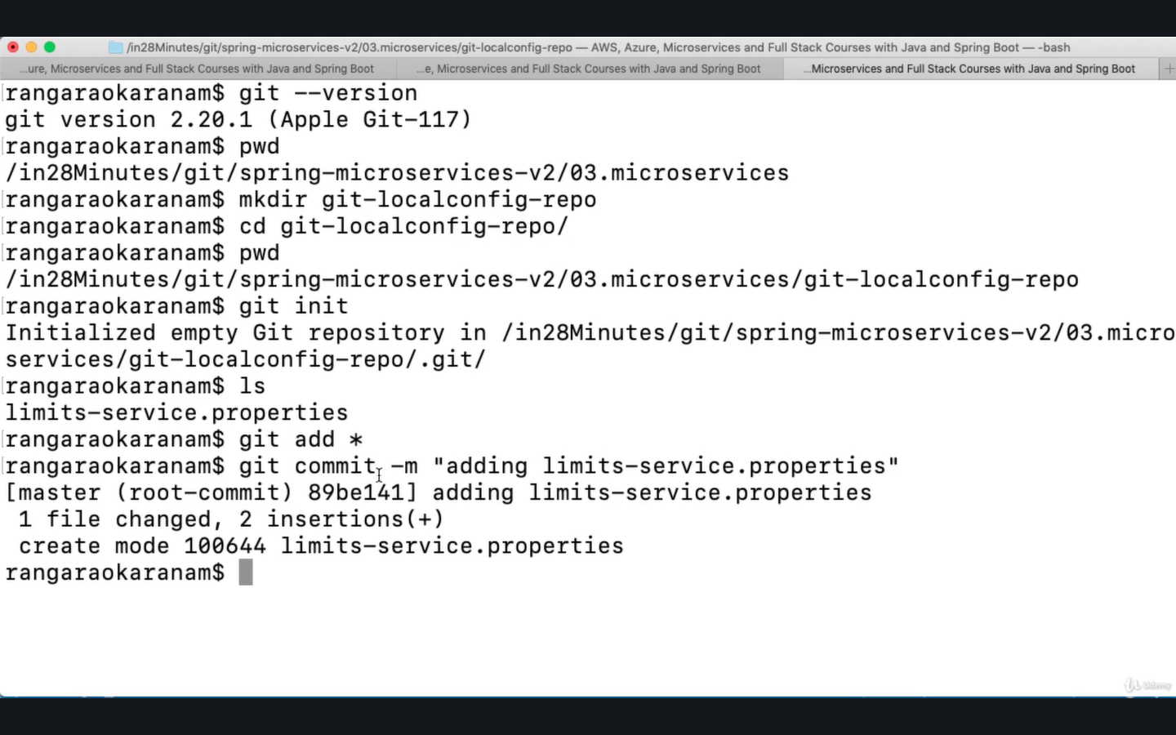

Debugging problems with Spring Cloud Config Server - V2

**Debugging** microservices problems can be **difficult** as there are multiple components involved.

**Step by Step instructions** is provided in the **troubleshooting guide** to help you troubleshoot frequently occurring problems.

Using the **Chrome Browser** is recommended.

<https://github.com/in28minutes/spring-microservices-v2/blob/main/03.microservices/01-step-by-step-changes/microservices-v2-1.md#spring-cloud-config-server---steps-01-to-08>

**Connect Spring Cloud Server to Local Git Repository**

Go to application.properties of spring-cloud-config-server and configure folder

pwd command to see folder in command prompt. Copy path and put in application.properties

add value in application.properties:

spring.cloud.config.server.git.uri=file:/// path --- in ios <file:///in28minutes/git/spring-microservices-v2/03.microservices/git-localconfig-repo>

WINDOWS – file:/// followed by path with forward slashes

If you're using windows then the value would be something of this kind.

#file:///C:/Users/home/Desktop/yourProject/git-repo

In Windows, Typically we would use backslash.

Yes, but over here you can see that we are using forward slash everywhere.

So in your windows folder path, replace your backslash with forward slashes and make sure that you create something of this kind and send it as the value to this property.

**Add @EnableConfigServer in SpringCloudConfigServerApplication.java**

Save this file and restart application

Go to localhost:8888/limits-service/default

It will return propertySources in json response

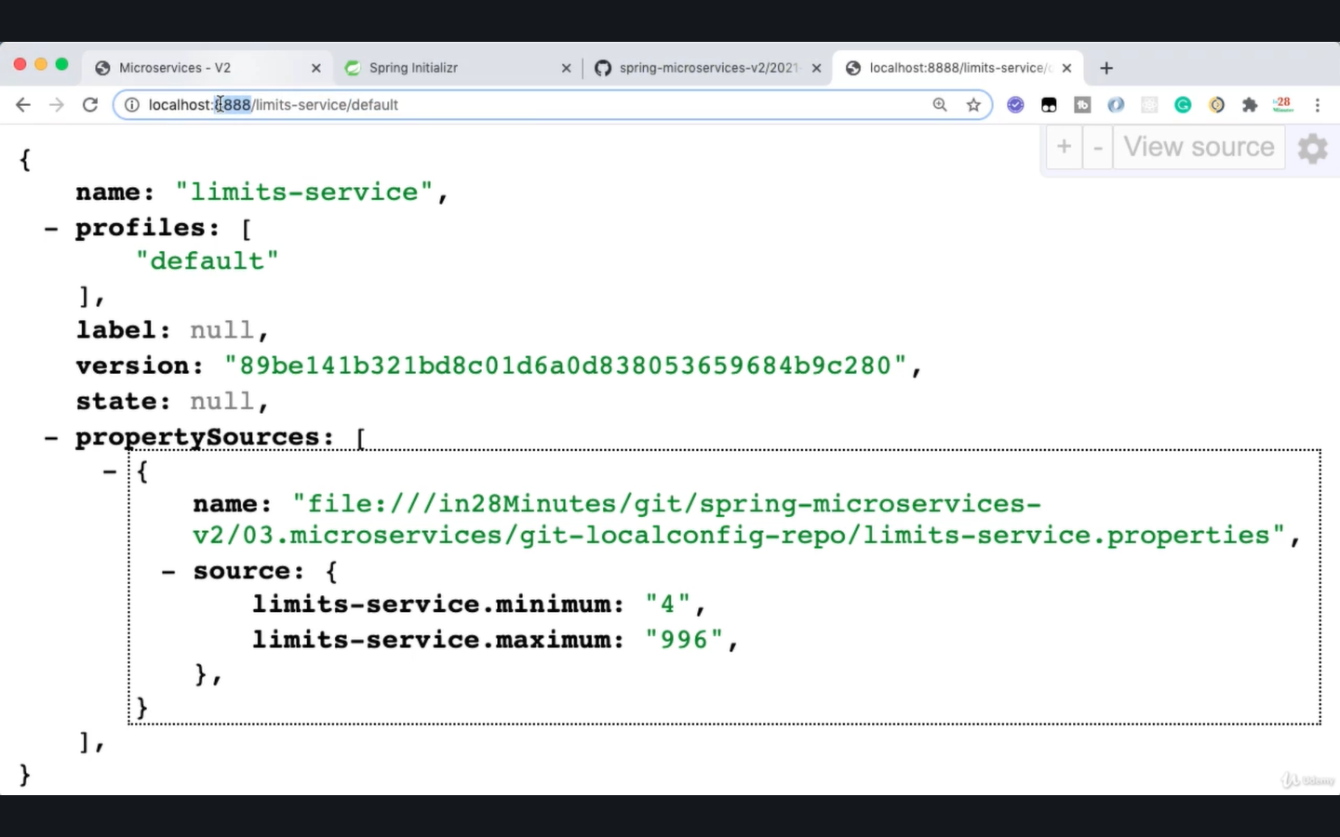

**Connect Limits Service to Spring Cloud Config Server – V2**

We’ll connect limits service to spring cloud config server

We’ve already select spring-cloud-starter-config in limits-service/pom.xml to talk with config server

Go to limit-service – application.properties

Add values to connect with config-server,

spring.application.name=limits-service

spring.config.import=optional:configserver:http://localhost:8888

Go to localhost:8080/limits and check minimum and maximum values will be retrieve from config server git local repository limits-service.properties

So when the limited service starts up, it executes : localhost:8888/limits-service/default {default is profile} usually on the cloud config server and it would get configuration in reponse.

**CODE BACKUP FILES and STEP BY STEP CHANGES : For Reference**

#### ****Help for Debugging Problems:****

1. Here's the code backup at the end of Step 07: <https://github.com/in28minutes/spring-microservices-v2/blob/main/03.microservices/step07.md>
2. Step by Step changes are detailed here:<https://github.com/in28minutes/spring-microservices-v2/blob/main/03.microservices/01-step-by-step-changes/microservices-v2-1.md#step-01>

#### ****Two Recommended Activities:****

**Activity - 1 :**Explore other backups for this section (Steps 08,10,13,15,21,25,29, final) - <https://github.com/in28minutes/spring-microservices-v2/tree/main/03.microservices>

**Activity - 2 :**Get Familiar with the structure of Step by Step changes file - <https://github.com/in28minutes/spring-microservices-v2/blob/main/03.microservices/01-step-by-step-changes/microservices-v2-1.md#step-01>

**Configuring Profiles for Limits Service**

Create copy of limits-service.properties in git local repo

Create limits-service-dev.properties & limits-service-qa.properties

Change minimum & maximum values

If you want to pickup configuration from dev & qa properties

Go to localhost:8888/limits-service/dev for dev configuration

Go to localhost:8888/limits-service/qa for qa configuration

Change profile in url for specific configuration

**To configure other environments:**

Go to limits-service -- application.properties and add

spring.profiles.active = dev

spring.cloud.config.profile = dev

Restart app , you will see active profile dev

Go to url: localhost:8080/limits, it will give dev environment minimum & maximum values

If you want to actually use a different name for your property file, then you can also configure it by using a property. #spring.cloud.config.name=

& that name would be used to fetch the configuration from the spring cloud config server.

You can do same to configure other microservices For ex. Microservice-x.properties & microservice-y.properties

The biggest advantage of going with this approach is now all your configuration related to your application is centralized

**Introduction to Currency Conversion & Exchange Microservices**

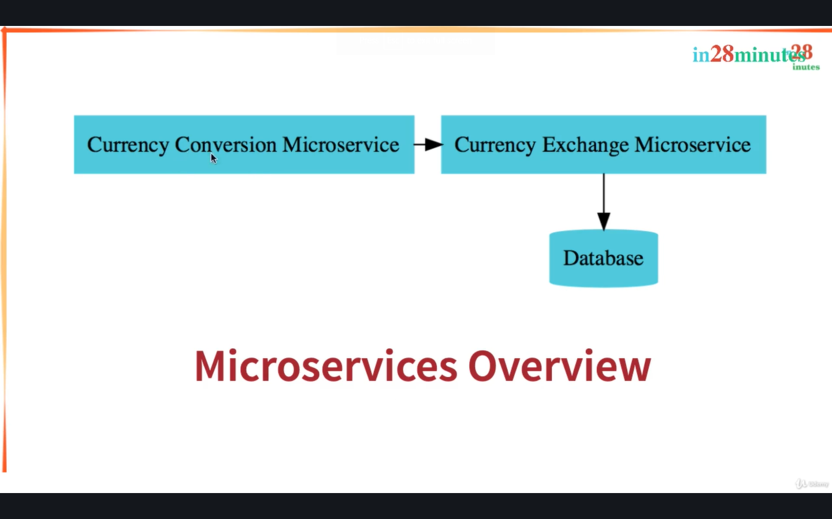

The currency exchange microservices, all about what is the exchange rate of one currency in another?

From the currency exchange microservices we would be exposing a simple url you are allowed to /currency-exchange/from USD/to/INR.

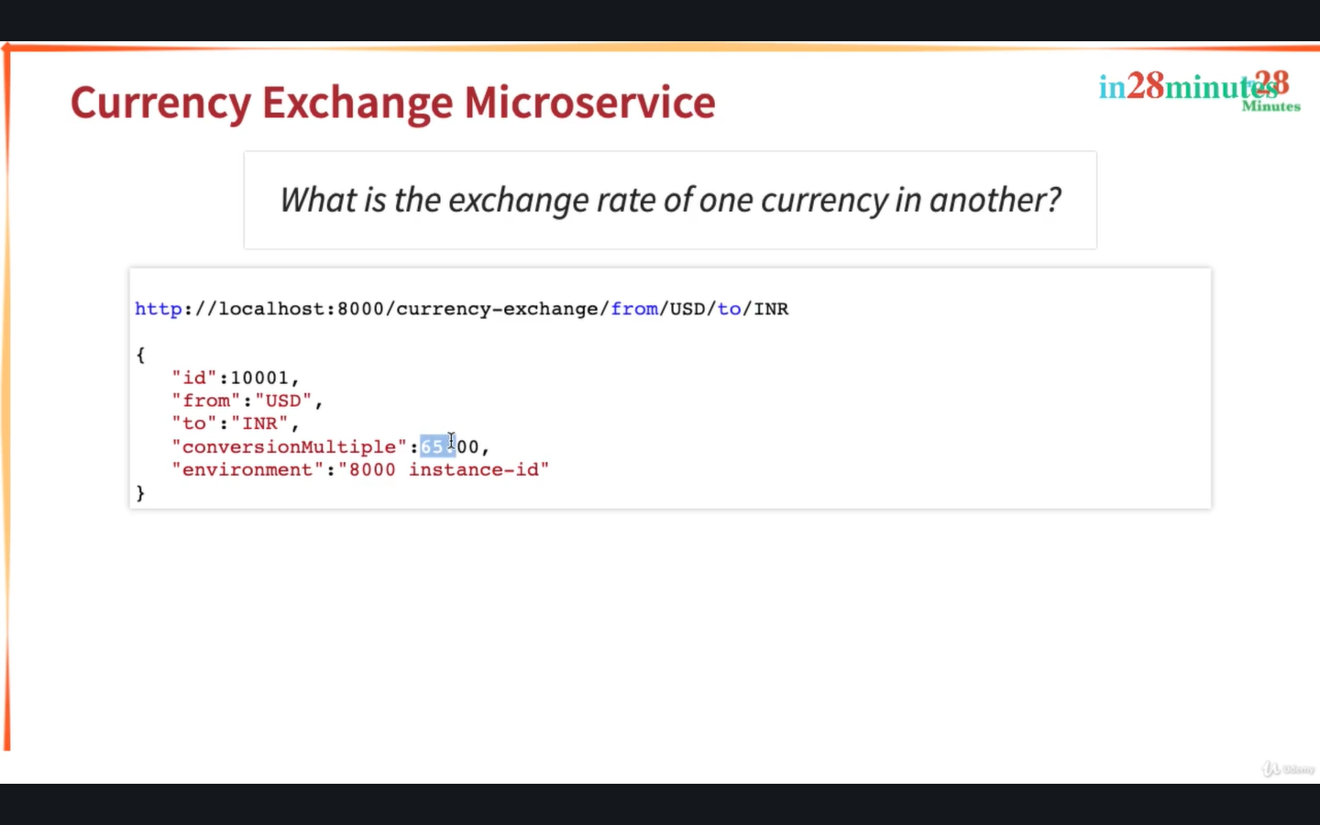

It would return back the conversion, multiplexing one USD 65 an hour. It Is saying 1 usd is 65 INR

The other microservices that we would want to set up is the currency conversion service.This is responsible for converting 10 USD into an INR.

The currency conversion service will call the currency exchange microdevices and ask what is the value of USD in INR today? And then it would take the return value that would be 65 and it would take it multiply it with 10 and

it would return this response back.

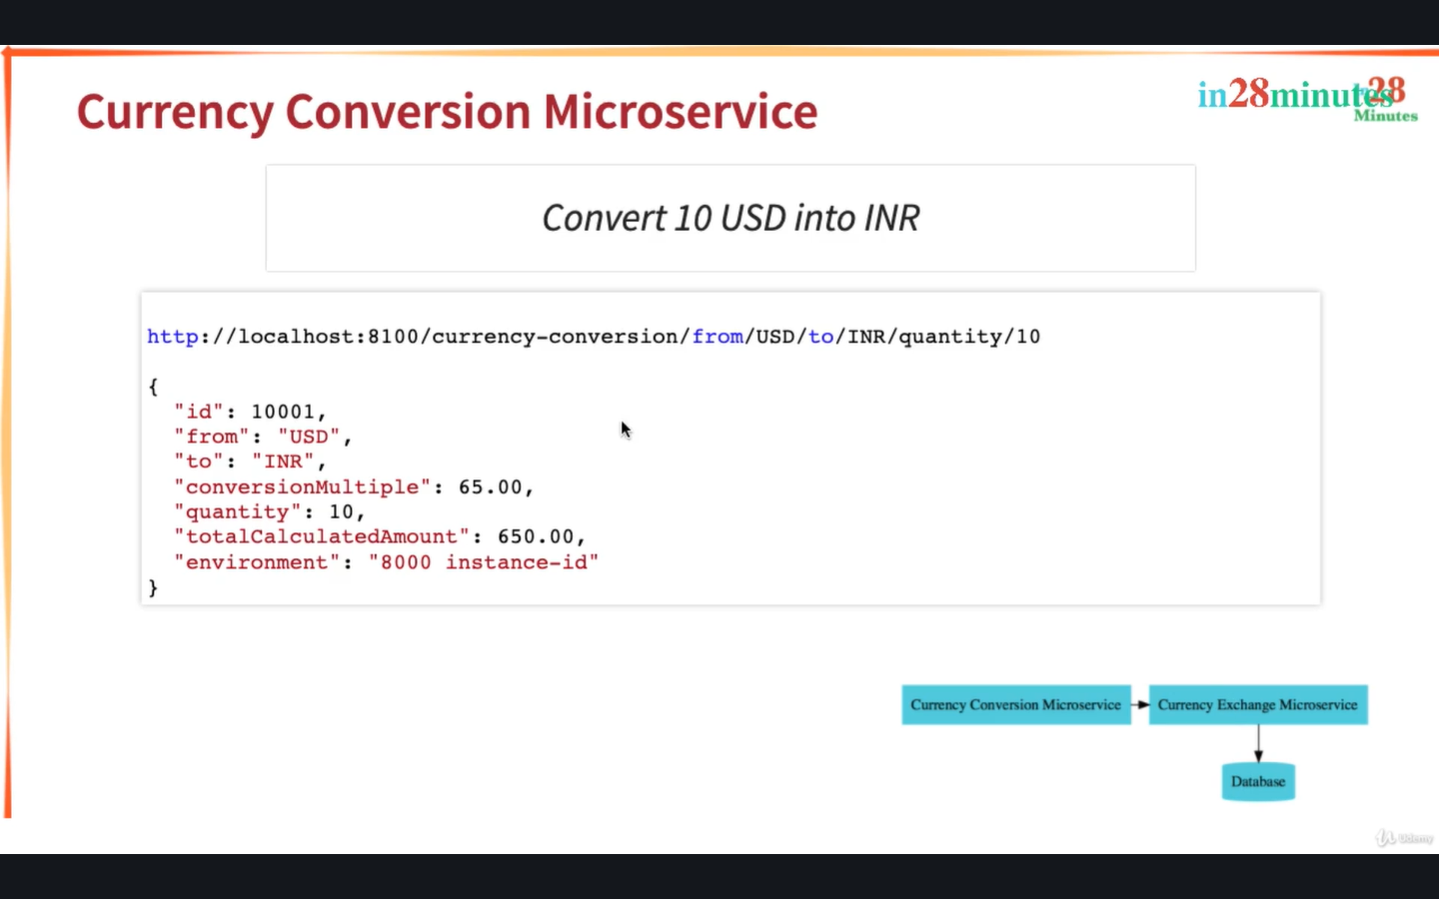

So these are two very, very simple macro services that we would be setting up.

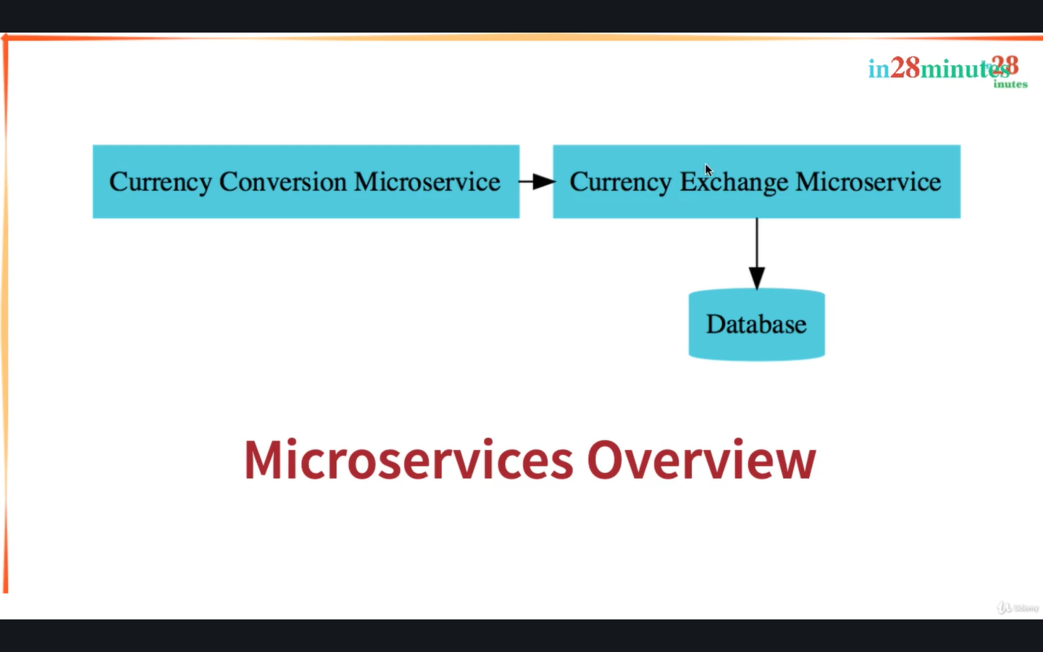

**Setting up Currency Exchange Microservice**

Go to spring.io, Create new spring project named currency-exchange-service

Group: com.in28minutes.microservices

Artifact: currency-exchange-service

Name: currency-exchange-service

Description: Demo project for Spring Boot

Add Dependencies:

* Spring Boot DevTools
* Spring Boot Actuator
* Spring Web
* Config Client

Generate project and unzip and import in sts

File🡪Import🡪existing maven project..choose folder../currency-exchange-service

Change port, Go to application.properties and add

* spring.application.name=currency-exchange
* server.port=8000

Save & Launch Application

Terminate Limit Service & Spring cloud config server

Delete Limit Service & Spring cloud config server (Do not tick delete project contents on disk)

**URL and Response Structure for Currency Exchange Service**

URL: http://localhost:8000/currency-exchange/from/USD/to/INR

Response Structure

{"id":10001, "from":"USD", "to":"INR", "conversionMultiple":65.00, "environment":"8000 instance-id"}

URLs will be using:

Currency Exchange Service

<http://localhost:8000/currency-exchange/from/USD/to/INR>

Currency Conversion Service

<http://localhost:8100/currency-conversion/from/USD/to/INR/quantity/10>

**Create a simple hard coded currency exchange service**

Create class CurrencyExchange

Public class CurrencyExchange{

private Long id;

private String from;

private String to;

private BigDecimal conversionMultiple;

}

Create constructor using fields, getters and setters & toString

Create class CurrencyExchangeController and add annotation @RestController

Create method retrieveExchangeValue

@GetMapping(“/currency-exchange/from/{from}/to/{to}”)

public CurrencyExchange retrieveExchangeValue(@PathVariable String from,@PathVariable String to){

return new CurrencyExchange(1000L,from,to,BigDecimal.valueOf(50));

}

Hit localhost:8000/currency-exchange/from/USD/to/INR

{

id:1000,

from: “USD”,

to: “INR”,

conversionMultiple: 50,

}

**Setting up Dynamic Port in the Response**

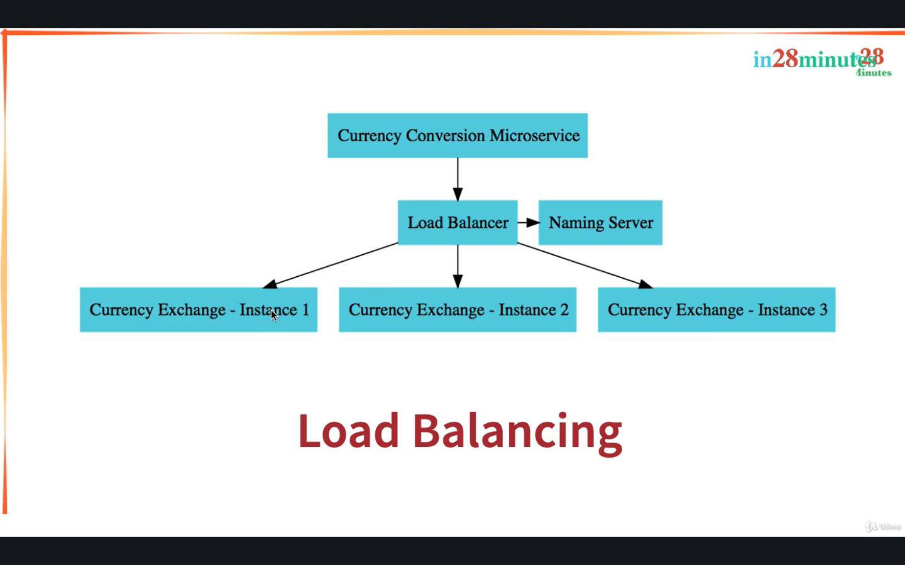

Add variable environment in CurrencyExchange

private String environment;

Add Getters & Setters

Inject private Environment environment in CurrencyExchangeController

**import** org.springframework.core.env.Environment;

**CurrencyExchangeController**

@Autowired

private Environment environment;

@GetMapping(“/currency-exchange/{from}/to/{to}”)

public CurrencyExchange retrieveExchangeValue(@PathVariable String from,@PathVariable String to){

CurrencyExchange currencyExchange = new CurrencyExchange(1000L,from,to,BigDecimal.valueOf(50));

String port = environment.getProperty(“local.server.port”);

currencyExchange.setEnvironment(port);

return currencyExchange;

}

It will return 8000 in response

We have to create two instance

Right Click on project and select run as button and select run configurations

Under Java Application..Select CurrencyExchangeServiceApplication and rename with CurrencyExchangeServiceApplication8000

Apply and right click on CurrencyExchangeServiceApplication8000 and select Duplicate named as CurrencyExchangeServiceApplication8001

Go to Arguments - VM arguments and Add **–Dserver.port=8001**

It will override whatever in application.properties. Run service

And new instance will launched up go to console log to check.

Console: Tomcat started on 8001

To run this service, Go to localhost:8001/currency-exchange/from/USD/to/INR

**Configure JPA and Initialized Data**

Right now we have hardcoded rest. Let’s make it fetch from in-memory database and will be using JPA.

Go to currency-exchange-service/pom.xml

Add dependencies:

<dependency>

<groupId>org.springframework.boot</groupId>

<artifactId>spring-boot-starter-data-jpa</artifactId>

</dependency>

<dependency>

<groupId>com.h2database</groupId>

<artifactId>h2 </artifactId>

</dependency>

Save and stop all applications. Launch currency-exchange-service (port:8000 ) application.

Go to application.properties

Add values:

spring.jpa.show-sql = true

spring.datasource.url=jdbc:h2:mem:testdb

spring.h2.console.enabled=true

Go to localhost:8000/h2-console

JDBC URL: jdbc:h2:mem:testdb

Connect. You will see all tables and data.

Create JPAEntity to CurrencyExchange

Go to CurrencyExchange

We cannot use from variable, it will give us an error – SQLSyntaxError because we are using keyword in column name.

So add annotation :

@Column(name=”currency_from”)

private String from;

@Column(name=”currency_to”)

private String to

Mark @Entity in CurrencyExchange and @Id on Long id -(import javax.persistence.id)

Launch Application.It will create table for us.

Go to h2-console..Refresh.You will see Currency_Exchange table

To insert some data in our database. Create data.sql file in src/main/resources

**data.sql :**

insert into currency_exchange (id,currency_from,currency_to,conversion_multiple,environment) values(10001,’USD’,’INR’,65,’’);

insert into currency_exchange (id,currency_from,currency_to,conversion_multiple,environment) values(10002,’EUR’,’INR’,75,’’);

insert into currency_exchange (id,currency_from,currency_to,conversion_multiple,environment) values(10003,’AUD’,’INR’,25,’’);

This file will launch whenever we start our application.

Launch Application. You will see data in your h2-console table.

**CODE BACKUP FILES and STEP BY STEP CHANGES : For Reference**

#### ****Help for Debugging Problems:****

* Here's the code backup at the end of Step 13: <https://github.com/in28minutes/spring-microservices-v2/blob/main/03.microservices/step13.md>
* Step by Step changes are detailed here: <https://github.com/in28minutes/spring-microservices-v2/blob/main/03.microservices/01-step-by-step-changes/microservices-v2-1.md#step-13>

**Two Recommended Activities:**

**Activity - 1** : Explore other backups for this section (Steps 08,10,13,15,21,25,29, final) - <https://github.com/in28minutes/spring-microservices-v2/tree/main/03.microservices>

**Activity - 2** : Get Familiar with the structure of Step by Step changes file - <https://github.com/in28minutes/spring-microservices-v2/blob/main/03.microservices/01-step-by-step-changes/microservices-v2-1.md#step-13>

**Create a JPA Repository – V2**

Create interface CurrencyExchangeRepository in com.in28minutes.microservices.currencyexchangeservice

Extends JpaRepository<CurrencyExchange,Long>

**CurrencyExchangeRepository.java**

public interface CurrencyExchangeRepository extends JpaRepository<CurrencyExchange , Long>{

}

This interface is sufficient to talk to the database.

**Go to CurrencyExchangeRepository:**

Declare findByFromAndTo method, it will automatically implemented by JpaRepository:

CurrencyExchange findByFromAndTo(String from,String to);

**Go to** **CurrencyExchangeController:**

Declare CurrencyExchangeRepository and annotation @Autowired in CurrencyExchangeController

@Autowired

private CurrencyExchangeRepository repository;

**Update retrieveExchangeValue method**

@GetMapping(“/currency-exchange/from/{from}/to/{to}”)

public CurrencyExchange retrieveExchangeValue( @PathVariable String from,@PathVariable String to){

CurrencyExchange currencyExchange = repository.findByFromAndTo(from,to);

If(currencyExchange == null){

throw new RuntimeException

(“Unable to Find data for “+from+” to “+to);

}

String port = environment.getProperty(“local.server.port”);

currencyExchange.setEnvironment(port);

return currencyExchange;

}

Launch Application and hit :

localhost:8000/currency-exchange/from/USD/to/INR

It will fetch data from database

Reponse:

{

id: 10001,

from: “USD”,

to: “INR”,

conversionMultiple: 65,

environment: “8000”,

}

Also try and hit

* localhost:8000/currency-exchange/from/EUR/to/INR
* localhost:8000/currency-exchange/from/AUD/to/INR

We are not set up with the currency exchange micro service, it is talking to an in-memory database and we have created a simple rest API and now we will want to shift our attention to the currency conversion micro service.

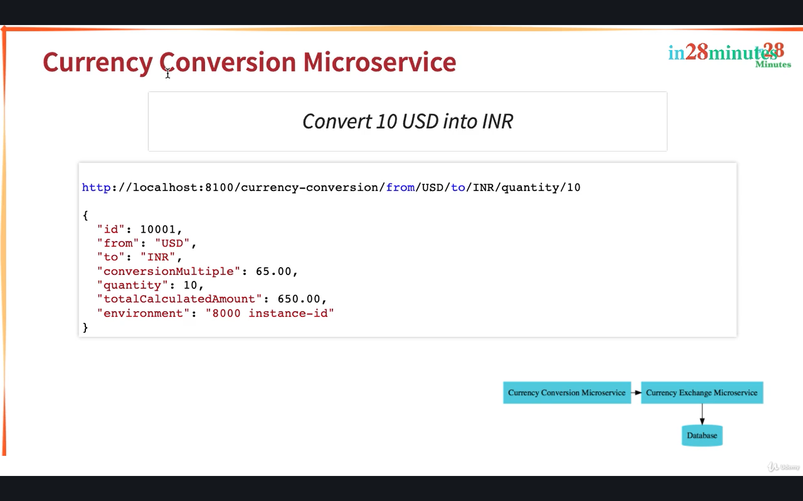

Let's quickly set it up right now.

Go to start.spring.io, Create new spring project named currency-conversion-service

Group: com.in28minutes.microservices

Artifact: currency-conversion-service

Name: currency- conversion -service

Description: Demo project for Spring Boot

Add Dependencies:

* Spring Boot DevTools
* Spring Boot Actuator
* Spring Web
* Config Client

Generate project and unzip and import in sts

File🡪Import🡪existing maven project..choose folder../currency-coversion-service

Change port,Go to application.properties and add

* spring.application.name=currency-conversion
* server.port=8100

Save & Launch Application

**URL and Response Structure for Currency Conversion Service**

**We will make use of these in the next lecture!**

**URL**: http://localhost:8100/currency-conversion/from/USD/to/INR/quantity/10

**Response**:

{

"id": 10001, "from": "USD", "to": "INR", "conversionMultiple": 65.00, "quantity": 10,

"totalCalculatedAmount": 650.00, "environment": "8000 instance-id"

}

**Creating a service for currency conversion**

Create new class CurrencyConversion in com.in28minutes.microservices.currencyconversionservice

private Long id;

private String from;

private String to;

private BigDecimal quantity;

private BigDecimal conversionMultiple;

private BigDecimal totalCalculatedAmount;

private String environment;

Create blank constructor,constructor using fields,Generate getters & setters

Create new class CurrencyConversionController in com.in28minutes.microservices.currencyconversionservice

Add Annotation RestController

Add method calculateCurrencyConversion and annotate with @GetMapping(“/currency-conversion/from/{from}/to/{to}/quantity/{quantity}”)

public CurrencyConversion calculateCurrencyConversion(

@PathVariable String from, @PathVariable String to,@PathVariable BigDecimal quantity){

return new CurrrencyConversion(10001L,from, to,quantity, BigDecimal.ONE, BigDecimal.ONE,””);

}

Go to localhost:8100/currency-conversion/from/USD/to/INR/quantity/10

Response : { id:10001,from: “USD”, to: “INR”, quantity: 10, conversionMultiple:1 , totalCalculatedAmount: 1,environment: “”, }

**Invoking Currency Exchange from Currency Conversion Microservice**

Update calculateCurrencyConversion method in CurrencyConversionController

import org.springframework.web.client.RestTemplate;

public CurrencyConversion calculateCurrencyConversion(

@PathVariable String from, @PathVariable String to,@PathVariable BigDecimal quantity){

HashMap<String,String> uriVariables = new HashMap<>();

uriVariables.put(“from”,from);

uriVariables.put(“to”,to);

ResponseEntity<CurrencyConversion> responseEntity = new RestTemplate().getForEntity

(“[http://localhost:8000/currency-exchange/from/{from}/to/{to}](http://localhost:8000/currency-exchange/from/%7bfrom%7d/to/%7bto%7d)”, CurrencyConversion.class, uriVariables);

CurrencyConversion currencyConversion = responseEntity.getBody();

return new CurrrencyConversion(currencyConversion.getId(),from, to,quantity, currencyConversion.getConversionMultiple(), quantity.multiply(currencyConversion. getConversionMultiple()), currencyConversion.getEnvironment());

}

Hit localhost:8100/currency-conversion/from/USD/to/INR/quantity/10

Response:

{

id: 10001, from: “USD”, to: “INR”, quantity:10, conversionMultiple: 65, totalCalculatedAmount: 650,

environment: “8000”,

}

**Using Feign REST Client for Service Invocation**

Go to currency-conversion-service/pom.xml

Add Feign Dependency:

<dependency>

<groupId>org.springframework.cloud</groupId>

<artifactId>spring-cloud-starter-openfeign</artifactId>

</dependency>

Restart application because you have made pom.xml changes

And what we would want to do is we would want to be able to talk to the currency-exchange-service from the CurrencyConversionController, and to be able to do that what we need to do is to create a proxy.

Create a new interface in currency-conversion-service/src/main/java named CurrencyExchangeProxy (it should be interface)

Go to CurrencyConversionServiceApplication class and Add Annotation i.e. @EnableFeignClients

Go to CurrencyExchangeProxy and add annotation i.e.

@FeignClient(name=”currency-exchange”,url=”localhost:8000”) //name is spring.application.name in application.properties

Go to CurrencyExchangeController and copy retrieveExchangeValue method and paste into CurrencyExchangeProxy to declare method with mapping

Change return method with CurrencyConversion, we have created the CurrencyConversion bean matching the structure of the response of the currency-exchange. And therefore the values, the return values are automatically mapped into the CurrencyConversion bean.

Save and run.

**CurrencyExchangeProxy.java**

package com.in28minutes.microservices.currencyconversionservice;

import org.springframework.cloud.openfeign.FeignClient;

import org.springframework.web.bind.annotation.GetMapping;

import org.springframework.web.bind.annotation.PathVariable;

@FeignClient(name=”currency-exchange”,url=”localhost:8000”)

public interface CurrencyExchangeProxy {

@GetMapping(“/currency-exchange/from/{from}/to/{to}”)

public CurrencyConversion retrieveExchangeValue(

@PathVariable String from,

@PathVariable String to);

}

We will use CurrencyExchangeProxy in CurrencyConversionController

Go to CurrencyConversionController ,Copy calculateCurrencyConversion method and paste and change mapping name into **@GetMapping(“/currency-coversion-feign/from/{from}/to/{to}/quantity/{quantity}”)** and change method name into **calculateCurrencyConversionFeign**

Remove RestTemplate Code.

Declare CurrencyExchangeProxy in CurrencyConversionController

**CurrencyConversionController**

@RestController

public class CurrencyConversionController{

@Autowired

private CurrencyExchangeProxy proxy;

@GetMapping(“/currency-coversion-feign/from/{from}/to/{to}/quantity/{quantity}”)

public CurrencyConversion calculateCurrencyConversionFeign(@PathVariable String from,@PathVariable String to,@PathVariable BigDecimal quantity) {

CurrencyConversion currencyConversion = proxy.retrieveExchangeValue(from,to);

return new CurrencyConversion(currencyConversion.getId() , from, to, quantity, currencyConversion.getConversionMultiple() , quantity.multiply(currencyConversion.getConversionMultiple()), currencyConversion.getEnvironment()+ “ “+ “feign”);

}

}

Go and hit localhost:8100/currency-conversion-feign/from/USD/to/INR/quantity/10

It will work! Response:

{ id:10001,from: “USD”, to: “INR”, quantity: 10, conversionMultiple: 65, totalCalculatedAmount: 650, environment: “8000”,

}

**Understand Naming Server and Setting up Eureka Naming Server**

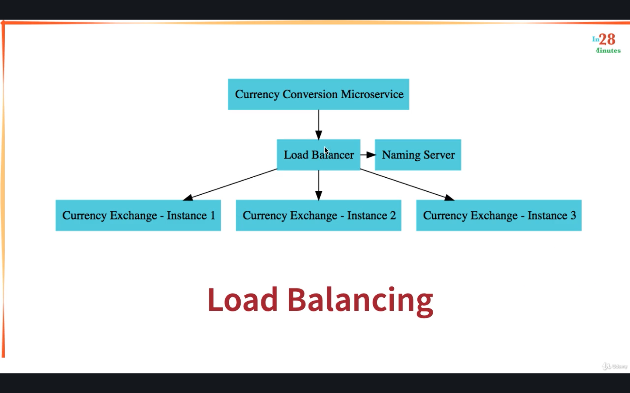

Let's say 8000 went down and let's say a new instance was brought up on 8002. Then you have to change the configuration of this application or the code of this application all the time. And that's the reason why we go for something called a service registry or a naming server.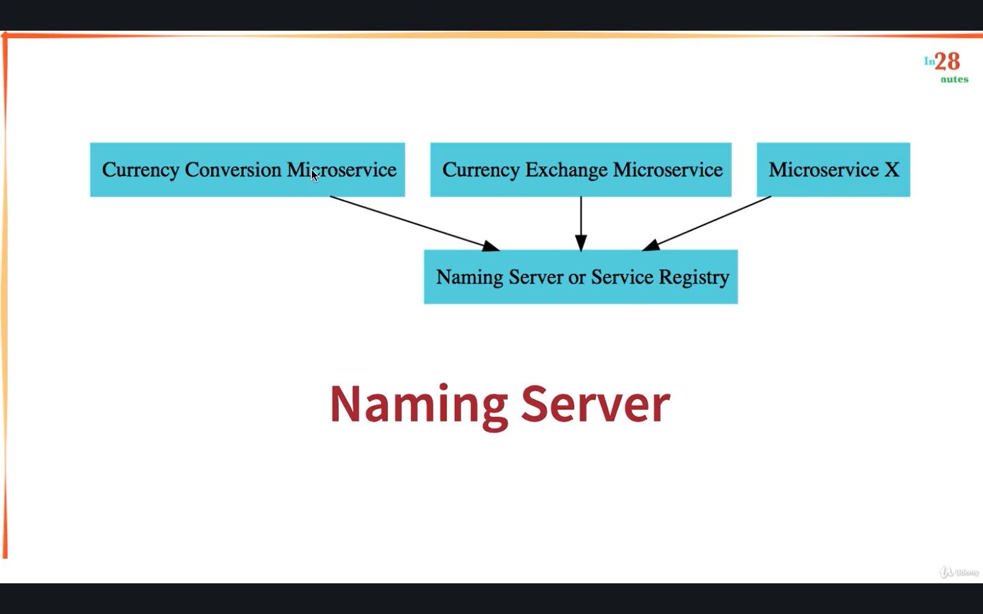

What would happen is in a microservice architecture, all the instances of all the microservices would register with a service registry.

So, the currency conversion microservice would register with the service registry, the currency exchange microservice would register with the service registry and all the other microservice also would register with the service registry.

Let's say the currency conversion microservice wants to talk to the currency exchange microservice, it would ask the service registry, hey, what are the addresses of the currency exchange microservice. The service registry would return those back to the currency conversion microservice and then the currency Conversion microservice can send the request out to the currency exchange microservice.

So, all the instances would register with the naming server or the service registry. And whenever currency conversion microservice wants to find out what are the active instances, It asks the naming server, gets the instances, and load balances between them.

Let's get started with creating a Naming Server in Spring Cloud. i.e. Eureka.

Go to start.spring.io , Create new spring project named naming-server

Group: com.in28minutes.microservices

Artifact: naming-server

Name: naming-server

Description: Demo project for Spring Boot

Add Dependencies:

* Spring Boot DevTools
* Spring Boot Actuator
* Config Client
* Eureka Server – Spring Cloud Discovery (spring-cloud-netflix)

Generate project and unzip and import in sts

File🡪Import🡪existing maven project..choose folder../naming-server

Click Finish and complete import.

You will see spring-cloud-starter-netflix-eureka-server dependency in pom.xml

Go to NamingServerApplication.java and add Annotation @EnableEurekaServer

**NamingServerApplication.java**

@EnableEurekaServer

@SpringBootApplication

public class NamingServerApplication{

public static void main (String[] args){

SpringApplication.run(NamingServerApplication.class,args);

}

}

Change port, Go to application.properties and add

* spring.application.name=naming-server
* server.port=8761
* eureka.client.register-with-eureka = false //because we do not want to connect this server with itself
* eureka.client.fetch-registry=false

Save & Launch Application (Few warnings which we can ignore)

It will start on localhost:8761 , Right now there is nothing registered with Eureka. You will see no instance available,

In the subsequent steps, we will get the currency-exchange-service and currency-conversion-service to talk to Eureka.

**Debugging** microservices problems can be **difficult** as there are multiple components involved. **Step by Step instructions** is provided in the **troubleshooting guide** to help you troubleshoot frequently occurring problems. Using the **Chrome Browser** is recommended.

<https://github.com/in28minutes/spring-microservices-v2/blob/main/03.microservices/01-step-by-step-changes/microservices-v2-1.md#eureka---step-19-to-21>

**Connect Currency Conversion & Currency Exchange Microservices**

Let's get the Currency Exchange Microservice and the Currency Conversion Microservice to register with the Naming Server.

Open currency-conversion-service/pom.xml and currency-exchange-service/pom.xml

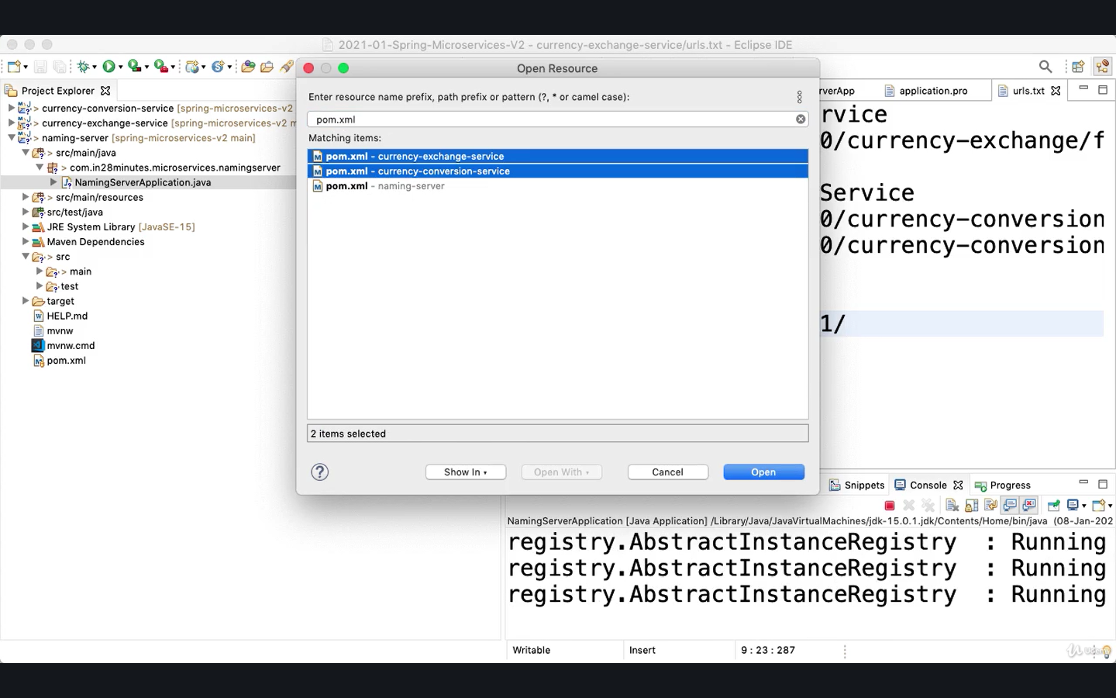

Go to currency-conversion-service/pom.xml

**Add Dependency:**

<dependency>

<groupId>org.springframework.cloud</groupId>

<artifactId>spring-cloud-starter-netflix-eureka-client</artifactId>

</dependency>

Go to currency-exchange-service/pom.xml

**Add Dependency:**

<dependency>

<groupId>org.springframework.cloud</groupId>

<artifactId>spring-cloud-starter-netflix-eureka-client</artifactId>

</dependency>

Stop both currency exchange application & currency conversion application, Only Application running i.e. Naming Server Application

Launch one of them first i.e. CurrencyExchangeServiceApplication8000 , it will launch up

And if you refresh Eureka right enough, you can see that currency-exchange is now registered with Eureka.

* Go to currency-exchange-service/application.properties and add property:
* eureka.client.serviceUrl.defaultZone = <http://localhost:8761/eureka>
* Go to currency-conversion-service/application.properties and add property:
* eureka.client.serviceUrl.defaultZone = <http://localhost:8761/eureka>

Save & Launch CurrencyConversionServiceApplication & refresh localhost:8761

You will see it is registered with Eureka Server on localhost:8761 , you will also see logs in naming server logs of currency-exchange,currency-conversion status UP & DOWN

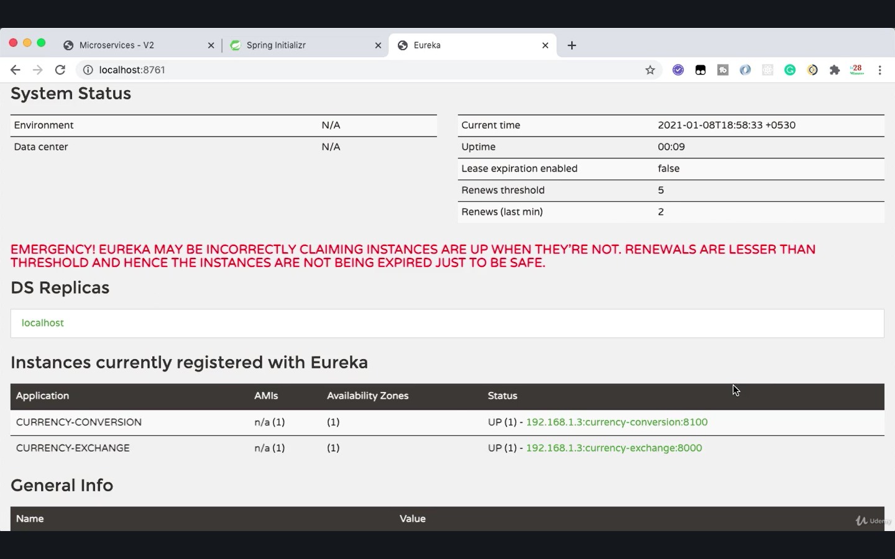

So, each time when you restart the application, first it would be unregistered and then it would be registered.

**To download zip go to Spring microservice –v2 Github repo -** [**https://github.com/in28minutes/spring-microservices-v2**](https://github.com/in28minutes/spring-microservices-v2)

When you extract the folder, you should see a folder inside there with the name 98.microservices-starting-point-for-v1-learners.

This contains the microservices , currency-conversion-service, currency-exchange-service, and the naming-server, that's Eureka, already set up for you.

So, all that you need to do is to go in into your Eclipse, File, Import, Existing Maven Projects, and select the specific folder, 98.microservices-starting-point-for-v1-learners and you can say Open and this would bring up two microservices and the naming server up. Launch applications:

* CurrencyConversionServiceApplication
* CurrencyExchangeServiceApplication
* NamingServerApplication

Currency Exchange Service

<http://localhost:8000/currency-exchange/from/USD/to/INR>

Currency Conversion Service

<http://localhost:8100/currency-conversion/from/USD/to/INR/quantity/10>

<http://localhost:8100/currency-conversion-feign/from/USD/to/INR/quantity/10>

Eureka

<http://localhost:8761>

Launch urls and check if it is running properly.

**Load Balancing with Eureka, Feign & Spring Cloud LoadBalancer**

Remove the url from annotation FeignClient in CurrencyExchangeProxy i.e.

@FeignClient(name=”currency-exchange”)

public interface CurrencyExchangeProxy{ }

Launch CurrencyExchangeServiceApplication8001 as well , it will register with eureka, you will see 2 instance will running in eureka.

Refresh currency-conversion-feign, you will see environment of 8001 & 8000

So, what is happening in here is, inside the Currency Conversion Microservice, there is a load balancer component which is talking to the naming server, finding the instances, and doing automatic load balancing between them.

And this is what is called client-side load balancing. And this is happening through feign. And how does feign do load balancing? If you actually go into our currency-conversion-service pom.xml

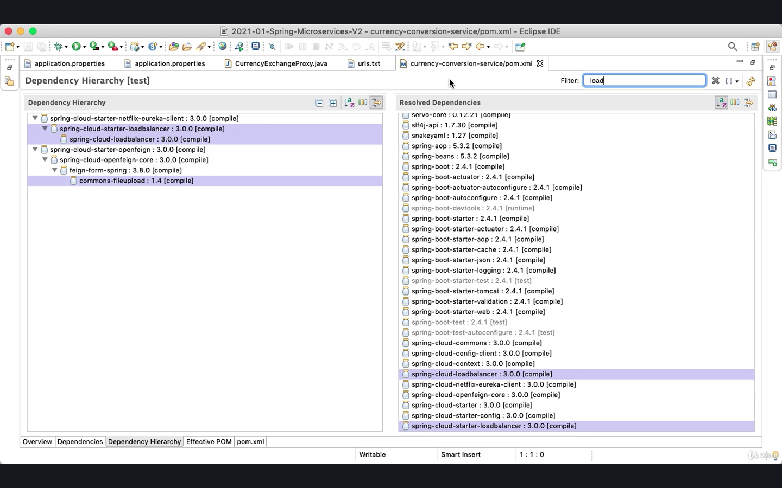

If you look at the dependency hierarchy which is present in here, and just type in load; l-o-a-d, standing for load balancer, you'd see that there is a load balancer, spring-cloud-starter-loadbalancer ,which is brought into the class path by spring-cloud-starter-netflix-eureka-client and this is the load balancer framework that is used by feign to actually distribute the load among the multiple instances which are returned by Eureka. In the earlier versions of Spring Cloud, the load balancer which was used was Ribbon and in the recent versions, Spring Cloud shifted to using Spring Cloud Load Balancer as the load balancer. The great thing is, if you're using Eureka and Feign, then load balancing comes for free. This is client-side load balancing and this comes for free for you.

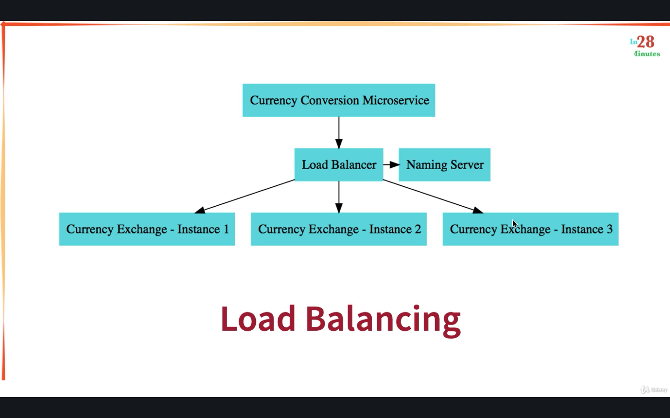

What I would recommend you to do is to stop certain instances of Currency Exchange and start new instances.

You would see that typically within 15 to 30 seconds, all the changes are reflected and the load balancing will be done between all the available active instances at that particular point in time. So, what we are creating in here is a very dynamic structure.

**Setting up Spring Cloud API Gateway**

These microservices have a lot of common features: authentication, authorization, logging, rate limiting.

Where do you implement all these common features?

The solution is to go for an API gateway. In the older versions of Spring Cloud, the popular API gateway to use was Zuul. Since Zuul is no longer supported by Netflix, Spring Cloud has moved on and now the recommended option as an API gateway is Spring Cloud Gateway. In this step, let's get started with implementing a Spring Cloud Gateway and look at the features it brings in.

Go to start.spring.io , Create new spring project named api-gateway

Group: com.in28minutes.microservices

Artifact: api-gateway

Name: api-gateway

Description: Demo project for Spring Boot

Add Dependencies:

* Spring Boot DevTools
* Spring Boot Actuator
* Config Client
* Eureka Discovery Client -Spring cloud discovery
* Gateway (api gateway,Spring cloud routing)

Generate project and unzip and import in sts

File🡪Import🡪existing maven project. .choose folder.. /api-gateway

Click Finish and complete import.

Change port, Go to application.properties and add

* spring.application.name=api-gateway
* server.port=8765
* eureka.client.serviceUrl.defaultZone=http://localhost:8761/eureka

Because of the Netflix Eureka client dependency, API Gateway would automatically register with Eureka. Launch ApiGateway application

Now if you go to Eureka and refresh, you should be able to see API Gateway in there as well. So, API Gateway , Currency Conversion and the Currency Exchange are the applications that are registered with Eureka right now.

**URLs for next Lecture**

Some of these URLs may be complex to write by hand: Refer back to here if you have problems in the next steps.

**Initial**

* http://localhost:8765/CURRENCY-EXCHANGE/currency-exchange/from/USD/to/INR
* http://localhost:8765/CURRENCY-CONVERSION/currency-conversion/from/USD/to/INR/quantity/10
* <http://localhost:8765/CURRENCY-CONVERSION/currency-conversion-feign/from/USD/to/INR/quantity/10>

**Lower Case**

* http://localhost:8765/currency-exchange/currency-exchange/from/USD/to/INR
* http://localhost:8765/currency-conversion/currency-conversion/from/USD/to/INR/quantity/10
* http://localhost:8765/currency-conversion/currency-conversion-feign/from/USD/to/INR/quantity/10

**Custom Routes**

* http://localhost:8765/currency-exchange/from/USD/to/INR
* http://localhost:8765/currency-conversion/from/USD/to/INR/quantity/10
* http://localhost:8765/currency-conversion-feign/from/USD/to/INR/quantity/10
* <http://localhost:8765/currency-conversion-new/from/USD/to/INR/quantity/10>

**Enabling Discovery Locator with Eureka for Spring Cloud Gateway**

Go to Eureka Server : localhost:8761

Pick application Name for eg. CURRENCY-EXCHANGE

From Eureka we will pickup application name i.e CURRENCY-EXCHANGE and we’re picking up the path of currency exchange service i.e. /currency-exchange/from/USD/to/INR

Before picking up the path, make sure currency exchange service is running

**API GATEWAY URL:**

API GATEWAY PORT : 8765

<http://localhost:8765/APPLICATION> NAME /api full url

<http://localhost:8765/CURRENCY-EXCHANGE/currency-exchange/from/USD/to/INR>

You will get an error if you will execute this.

However, as we see, it's not enabled yet. To enable this feature in Spring Cloud API gateway, we need to add in application.properties.

Open **api-gateway/application.properties** and add:

spring.cloud.gateway.discovery.locator.enabled=true

By default, this is disabled.We would want to enable service discovery by using discovery client (by adding this property). This is possible because in our pom.xml, we already have Netflix Eureka client and the API gateway is already registered with Eureka and it can discover other services also from Eureka.

Restart application and Go to <http://localhost:8765/CURRENCY-EXCHANGE/currency-exchange/from/USD/to/INR>

It will give response

Similarly Create other service url and go to url and check

* http://localhost:8765/CURRENCY-CONVERSION/currency-conversion/from/USD/to/INR/quantity/10
* <http://localhost:8765/CURRENCY-CONVERSION/currency-conversion-feign/from/USD/to/INR/quantity/10>

It will work fine! So, you can see that now you can call any microservice which is registered with Eureka through the API Gateway.

**If you'd want to implement things like authentication, you can implement them on API Gateway and you can only allow those things which are authenticated in your microservices. So, all the authentication logic can be implemented on the API gateway.**

**To make Api Gateway URL (application name) in lowercase,**

**Go to api –gateway/application.properties and add:**

* spring.cloud.gateway.discovery.locator.lowerCaseServiceId=true

Now API Gateway Service URls are:

<http://localhost:8765/application> name/api full url

* <http://localhost:8765/currency-exchange/currency-exchange/from/USD/to/INR>
* http://localhost:8765/currency-conversion /currency-conversion/from/USD/to/INR/quantity/10
* [http://localhost:8765/ currency-conversion /currency-conversion-feign/from/USD/to/INR/quantity/10](http://localhost:8765/CURRENCY-CONVERSION/currency-conversion-feign/from/USD/to/INR/quantity/10)

**Debugging** microservices problems can be **difficult** as there are multiple components involved.

**Step by Step instructions** is provided in the **troubleshooting guide** to help you troubleshoot frequently occurring problems.

Using the **Chrome Browser** is recommended.

<https://github.com/in28minutes/spring-microservices-v2/blob/main/03.microservices/01-step-by-step-changes/microservices-v2-1.md#spring-cloud-api-gateway---step-22-to-step-25>

**Exploring Routes with Spring Cloud Gateway**

To build custom routes in Api Gateway,

Create new class named ApiGatewayConfiguration in api-gateway project

Add Annotation @Configuration because this would contain few bean

**ApiGatwayConfiguration.java**

import org.springframework.cloud.gateway.route.RouteLocator;

import org.springframework.cloud.gateway.route.builder.RouteLocatorBuilder;

import org.springframework.context.annotation.Bean;

import java.util.function.Function;

@Configuration

public class ApiGatewayConfiguration{

**@Bean**

public RouteLocator gatewayRouter(RouteLocatorBuilder builder){

// when we do not customize any routes -- return builder.routes(). build();

Function<PredicateSpec , Buildable<Route>> routeFunction = p -> p.path(“/get”) //(predicate) if path is /get

.filters(f -> f .addRequestHeader(“MyHeader”,”MyURI”)

.addRequestParameter(“Param”,”MyValue))

// lambda function before routing to url we can add headers/parameters //for eg. Authentication parameter

.uri(“http://httpbin.org:80”); //then redirect to uri

return builder.routes()

.route(routeFunction)

.build();

} }

Right click on routeFunction 🡪 Refactor 🡪 Inline

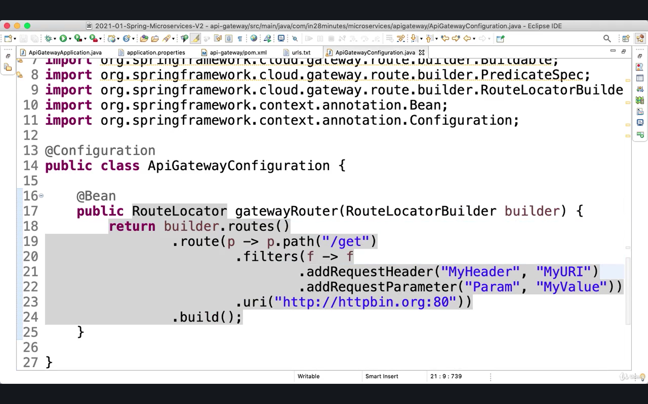

If you will go to localhost:8765/get you will get response back with headers

from specific server.i.e. <http://httpbin.org:80> which is api , you will also see

Myheader: “MyURI” in headers & Param in args

We will change Api Gateway Url –Right now currency-exchange(application name) is repeating twice in url.

What we will do is actually look for /currency-exchange and then redirect to the naming server.

**Go to api-gateway/application.properties and comment locator.enable & locator.lowerCaseServiceId**

#spring.cloud.gateway.discovery.locator.enabled = true

#spring.cloud.gateway.discovery.locator.lowerCaseServiceId = true

Add new route in gatewayRouter method in ApiGatewayConfiguration.java

.route(p -> p.path(“/currency-exchange/**”)

.uri(“lb://currency-exchange”) //redirecting with load balancing

// So, if a request starts with currency-exchange, what I would want to do over here is talk to Eureka, find the location of this service and load balance between the instances which are written.

So, let's pick up the new URL, currency-exchange/from/USD/to/INR and type this in.

localhost:8765/currency-exchange/from/USD/to/INR is new url

To do same changes do for other service and add route with that service name

.route(p -> p.path(“/currency-exchange/**”) .uri(“lb://currency-exchange”))

.route(p -> p.path(“/currency-conversion/**”) .uri(“lb://currency- conversion”))

.route(p -> p.path(“/currency-conversion-feign/**”) .uri(“lb://currency- conversion”))

You can even create new URLs and rewrite them. So, let's say, instead of currency-conversion-feign you would want to actually call something else for eg. currency-conversion-new and this one also you would want to redirect to currency-conversion-feign. You can do things like that as well in your API gateway.

Go to the ApiGatewayCeconfiguration and create a new route.

To redirect it to the feign, you would want to rewrite the URL and redirect it to the feign URL. So, in that kind of situation, I would need to add a filter to do that.

//f.rewritePath(stringTobeReplace , replaceWith)

It would have been easy if it was as simple as that, but what we would need to actually do is we would want to define the regular expression, identifying the next thing as a segment.

How do you define a regular expression identifying this as a specific segment?

Add ?<segment>.* and following this we can over here

So, whatever follows currency-conversion-new, you would want to append it to currency-conversion-feign. The way you can do that in here is by saying ${segment}.

.route(p -> p.path(“/currency-conversion-new/**”) .filters(f -> f.rewritePath( “/currency-conversion-new/(?<segment>.*)”, ”/ currency-conversion-feign/${segment}”))

.uri(“lb://currency- conversion”))

Go to currency-conversion-new/from/USD/to/INR/quantity/10 to check

**ApiGatewayConfiguration.java**

package com.in28minutes.microservices.apigateway;

|  |  |
| --- | --- |
|  | import org.springframework.cloud.gateway.route.RouteLocator; |
|  | import org.springframework.cloud.gateway.route.builder.RouteLocatorBuilder; |
|  | import org.springframework.context.annotation.Bean; |
|  | import org.springframework.context.annotation.Configuration; |
|  |  |
|  | @Configuration |
|  | public class ApiGatewayConfiguration { |
|  |  |
|  | @Bean |
|  | public RouteLocator gatewayRouter(RouteLocatorBuilder builder) { |
|  | return builder.routes() |
|  | .route(p -> p |
|  | .path("/get") |
|  | .filters(f -> f |
|  | .addRequestHeader("MyHeader", "MyURI") |
|  | .addRequestParameter("Param", "MyValue")) |
|  | .uri("http://httpbin.org:80")) |
|  | .route(p -> p.path("/currency-exchange/**") |
|  | .uri("lb://currency-exchange")) |
|  | .route(p -> p.path("/currency-conversion/**") |
|  | .uri("lb://currency-conversion")) |
|  | .route(p -> p.path("/currency-conversion-feign/**") |
|  | .uri("lb://currency-conversion")) |
|  | .route(p -> p.path("/currency-conversion-new/**") |
|  | .filters(f -> f.rewritePath( |
|  | "/currency-conversion-new/(?<segment>.*)", |
|  | "/currency-conversion-feign/${segment}")) |
|  | .uri("lb://currency-conversion")) |
|  | .build(); |
|  | } |
|  |  |
|  | } |

Now API Gateway Service URls are:

http://localhost:8765/api full url

* http://localhost:8765/currency-exchange/from/USD/to/INR
* http://localhost:8765/currency-conversion/from/USD/to/INR/quantity/10
* http://localhost:8765/currency-conversion-feign/from/USD/to/INR/quantity/10
* <http://localhost:8765/currency-conversion-new/from/USD/to/INR/quantity/10>

**Implementing Spring Cloud Gateway Logging Filter**

In last step , we saw how we can actually add custom filters on specific paths. To add global filters in API Gateway, Let's say, We would want to log every request that goes through the API gateway, and for that, We would want to create a new filter

It is need to implement to be able to do something and then do the execution of the request.

Create new class named LoggingFilter and implements GlobalFilter

Add unimplemented methods i.e. filter method and Declare Logger :

**Add Annotation component**

**LoggingFilter.java**

import org.slf4j.Logger;

import org.slf4j.LoggerFactory;

import org.springframework.cloud.gateway.filter.GatewayFilterChain;

import org.springframework.cloud.gateway.filter.GatewayFilter;

import org.springframework.web.server.ServerWebExchange;

import reactor.core.publisher.Mono;

**@Component**

public class LoggingFilter implements GLobalFilter {

private Logger logger = LoggerFactory.getLogger(LoggingFilter.class);

@Override

public Mono<Void> filter(ServerWebExchange exchange, GatewayFilterChain chain){

logger.info(“Path of the request received -> {}”,exchange.getRequest().getPath());

return chain.filter(exchange);

}

Restart application and run any api gateway urls and it will log in sts console. You can log other information about the request and if you'd want to implement things like authentication for all the requests, then this might be a right place to implement that as well.

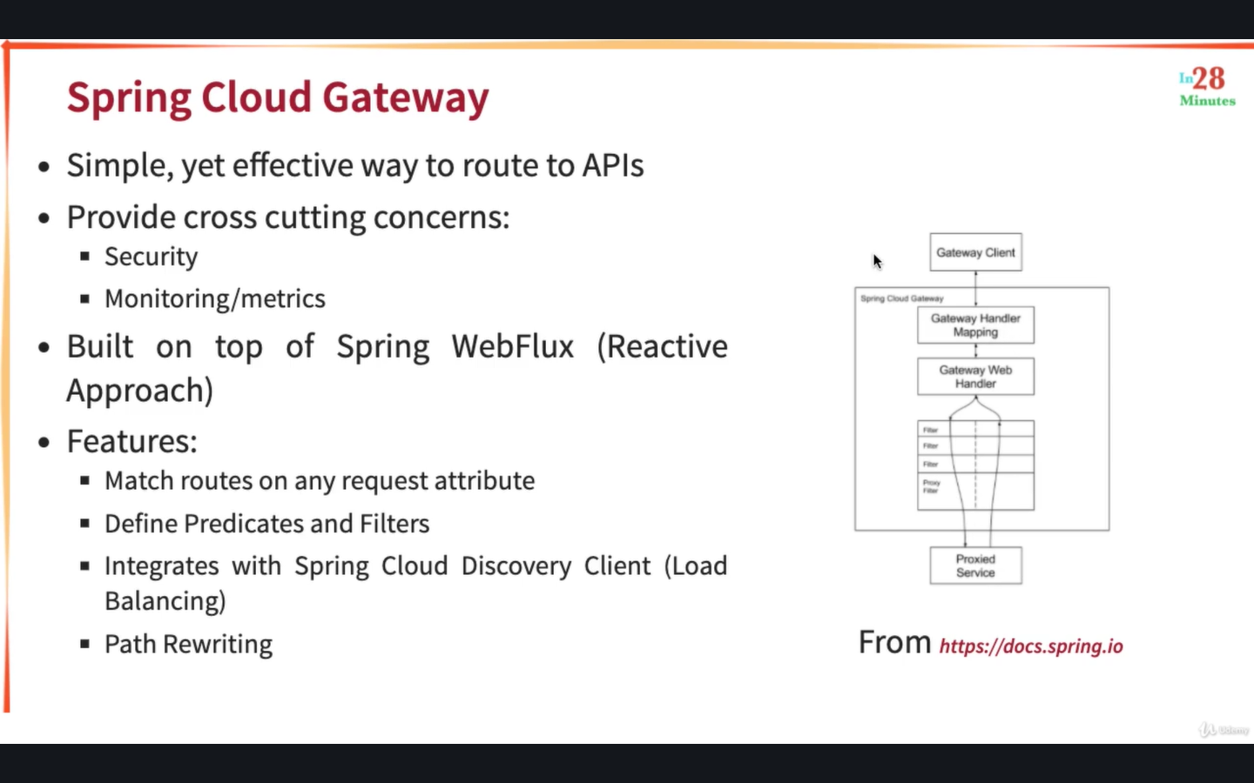

Earlier, we saw how you can actually match based on the path.

In addition to that, actually, you can match based on a lot of different things.

So, if you scroll down, you can match based on headers, you can match based on host, headers, query parameters, request method, based on a lot of different parameters.

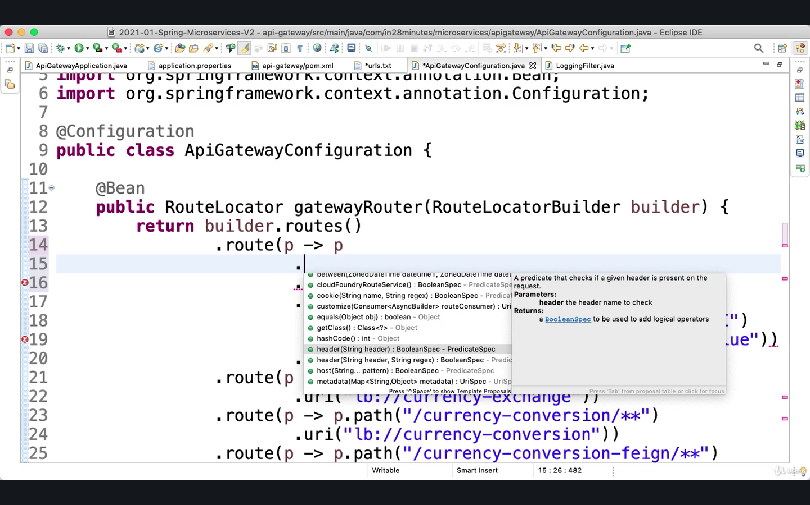

**Getting started with Circuit Breaker – Resilence4j**

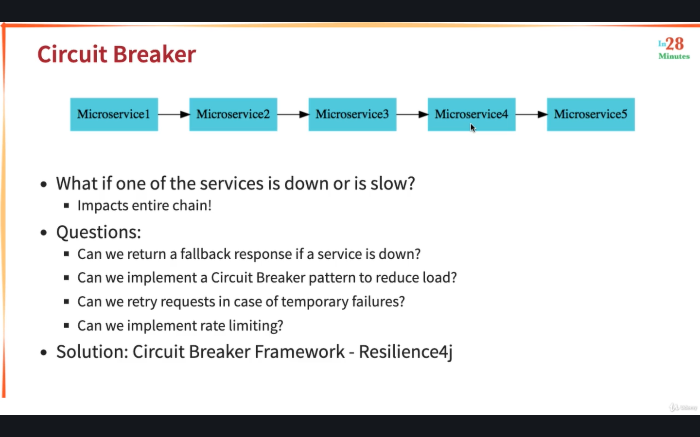

**We will need Actuator , AOP , Resilence4j dependencies to implement Resilience4j**

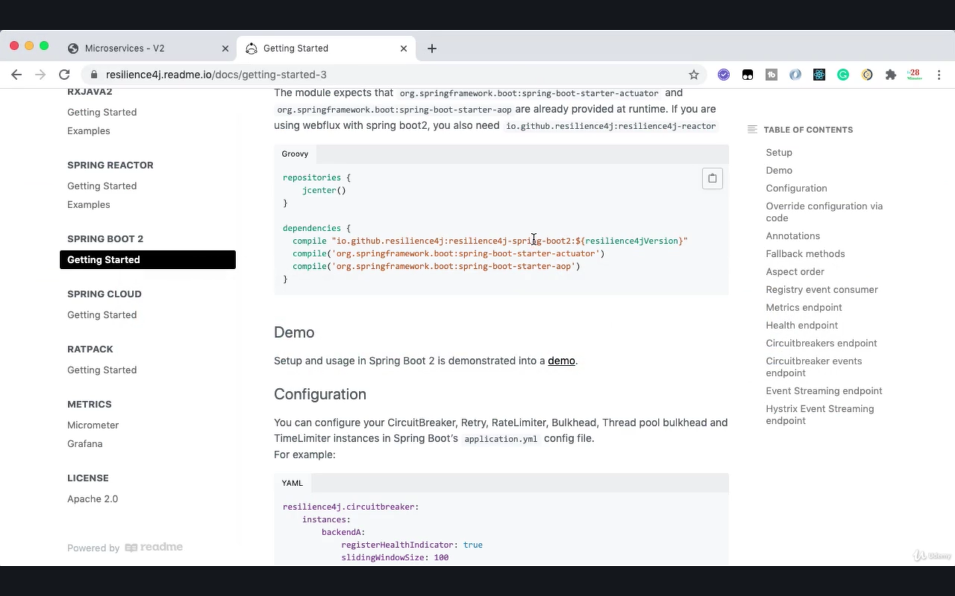

Stop all the running microservices.

Add Dependencies in currency-exchange-service/pom.xml

<dependency>

<groupId>org.springframework.boot</groupId>

<artifactId>spring-boot-starter-aop</artifactId>

</dependency>

<dependency>

<groupId>io.github.resilience4j</groupId>

<artifactId> resilience4j –spring-boot2</artifactId>

</dependency>

//If you do ctrl+click on resilence4j then you will see managed location for io.github. resilence4j and you will see which version you are using.

Create new class named CircuitBreakerController in com.in28minutes.microservice.currencyexchangeservice

Add Annotation @RestController and create new method sampleApi which returns string “Sample API” & add @GetMapping(“/sample-api”)

**CircuitBreakerController.java**

@RestController

public class CircuitBreakerController{

@GetMapping(“/sample-api”)

public String sampleApi(){

return “Sample API”;

}

}

**Playing with Resilence4j – Retry and Fallback Methods**

We'll add some logic in here which causes failures.

Create RestTemplate and call a dummy API which will fail to test Resilence4j

So, let's say, localhost:8080/some-dummy-url

ResponseEntity<String> forEntity = new RestTemplate().getForEntity(“<http://localhost:8080/some-dummy-url>”,String.class);

If you will call this you will get error, Now, let's say this microservice which we are calling is down temporarily and sometimes you know that if you invoke the same thing multiple times, it might give you a response back. And in those kinds of situations, you can go for a retry.

Add @Retry(name=”default”) annotation on sampleApi method in CircuitBreakerController

Add Logger to check if it is hit again for retry

It will get failed and will auto retry 3 three times (See in console logs)

**CircuitBreakerController.java**

@RestController

public class CircuitBreakerController{

private Logger logger = LoggerFactory.getLogger(CircuitBreakerController.class);

@GetMapping(“/sample-api”)

@Retry(name=”default”)

public String sampleApi(){

logger.info(“Sample api call received”);

ResponseEntity<String> forEntity = new RestTemplate().getForEntity(“<http://localhost:8080/some-dummy-url>”,String.class);

return forEntity.getBody();

}

}

The properties resilience4j, we are configuring retry and instances, and we can give the name. So, for different services, you can have different kinds of retry configurations.

To create our own specific retry configuration.

Update name in @Retry annotation. @Retry(name=”sample-api”) to call maxRetyAttempts value from application.properties

Go to currency-exchange-service/application.properties and add:

* resilience4j.retry.instances.sample-api.maxRetryAttempts=5

It will retry for 5 times now when it will fail.

To configure fallbackMethod : add parameter in @Retry annotation with method name:

**CircuitBreakerController.java**

@RestController

public class CircuitBreakerController{

private Logger logger = LoggerFactory.getLogger(CircuitBreakerController.class);

@GetMapping(“/sample-api”)

@Retry(name=”sample-api”, fallbackMethod=”hardcodedResponse”)

public String sampleApi(){

logger.info(“Sample api call received”);

ResponseEntity<String> forEntity = new RestTemplate().getForEntity(“<http://localhost:8080/some-dummy-url>”,String.class);

return forEntity.getBody();

}

public String hardcodedResponse(Exception ex){

return “fallback-response”;

}

}

You can actually use any exception in here and you can also have different responses returned back for different kinds of exception. So, if you get a runtime exception, you would want to do something else.

You will get fallback-response back, and if you go in, you can see that five retries happened and at the end of the five retries, the API call was still not successful and therefore, the fallback-response is returned back.

To configure what should be the interval between retries. So, if an API call is failing, It would wait for a little while and then make the API call again. We can configure how much time to wait for.

Go to application.properties and add:

resilience.retry.instances.sample-api.waitDuration=1s

To configure enableExponentialBackoff , Go to application.properties and add:

resilence4j.retry.instances.sample-api.enableExponentialBackoff=true

Because each subsequent request it would wait for a little longer.

for eg. 1 second then 2 second then 4 second then 8.

**Playing with Circuit Breaker Features of Resilience4j**

Comment @Retry annotation on sampleApi method in CircuitBreaker

Add @CircuitBreaker(name=“default”,fallbackMethod=”hardcodedResponse”)

Launch Eureka - NamingServerApplication to avoid connection exception

Launch currency-exchange-service

Now, to see the magic of CircuitBreaker, what we would need to do is to fire a lot of requests to this specific API.

To fire a lot of request to specific api :

In unix : watch command is use to fire a lot of requests in terminal

In windows : fire 100-200 quick requests from the browser by quickly refreshing!

* Unix watch command :
  + watch curl <http://localhost:8000/sample-api>
  + It will send a request every two seconds.
* To send a request every 0.1 second :
  + watch –n 0.1 curl <http://localhost:8000/sample-api>

Api will hit but it will not call method after some requests, it will directly call to fallbackResponse.

You will see in console is that the CircuitBreaker Sample api is being called up to a certain extent. You will not see method logs in console.. It will hit in interval.

You can see that there is no log being generated in console. That means the method is not being called, directly the fallback method is being called and the response is returned back.

If microservice is down then it will not call it and add load to it. It will return a default response back directly.  that is what the CircuitBreaker does. It will break the circuit and it will directly return a response back.

If you go to the resilience4j documentation and click CircuitBreaker,you'd see that there are multiple states for a CircuitBreaker.

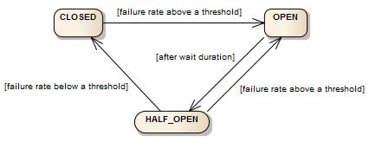

A circuit breaker can be in three different states: CLOSED, OPEN and HALF_OPEN.

Closed is when I am calling the dependent microservice continuously.

In a closed state, I'll always be calling the dependent microservice.

In a open state, the CircuitBreaker will not call the dependent microservice,it would directly return the fall-back response.

In a half_open state, a CircuitBreaker would be sending a percentage of requests to the dependent microservice and for rest of the requests, it would return the hardcoded response or the fall-back response back.

When does a CircuitBreaker switch from one state to another?

For example, the CircuitBreaker is in the closed state. When you start the application up, the CircuitBreaker is typically in a closed state. Let's say, I'm calling the depenedent microservice 10,000 times and I see that all of them are failing or I see that 90 percent of them are failing.In that kind of scenario, the CircuitBreaker would switch to a open state.Once it switches to an open state, it waits for a little while , there's a wait duration that you can configure. After that wait duration, the CircuitBreaker would switch to a half_open state. During the half_open state, the CircuitBreaker would try and see if the dependent microservice is up.So, it sends a percentage of the request, you can configure how much percentage it would send, let's say 10% or 20% of the requests to the dependent microservice, and if it gets proper responses for that, then it would go back to the closed state. If it does not get proper responses, then it would go back to the open state.

If you see the documentation, you can see that there are a wide range of things that you can configure on the CircuitBreaker. i.e. failureRateThreshold , slowCallRateThreshold , slowCallDurationThreshold , etc.

Click Spring Boot 2 for detailed documentation from yaml file

To customize percentage :

Go to application.properties and add :

resilience4j.circuitbreaker.instances.default.failureRateThreshold=90

So, We would want to increase the failureRateThreshold to 90%. Only if 90% of the requests fail, then we would want to switch to a open state.

**Exploring Rate Limiting and BulkHead Features of Resilience4j**

Comment CircuitBreaker

Add @RateLimiter(name=”default”) annotation to limit request. We can add in different api’s with different names. It will hit max 10000 calls in 10s to the api.

To configure this limits , go to application.properties & add:

resilience4j.ratelimiter.instances.default.limitForPeriod=2

resilience4j.ratelimiter.instances.default.limitRefreshPeriod=10s

It will allow two requests in every 10 seconds.

return “sample-api” in sampleApi method to test this.

It will give error if more than 2 request will hit in 10 seconds.

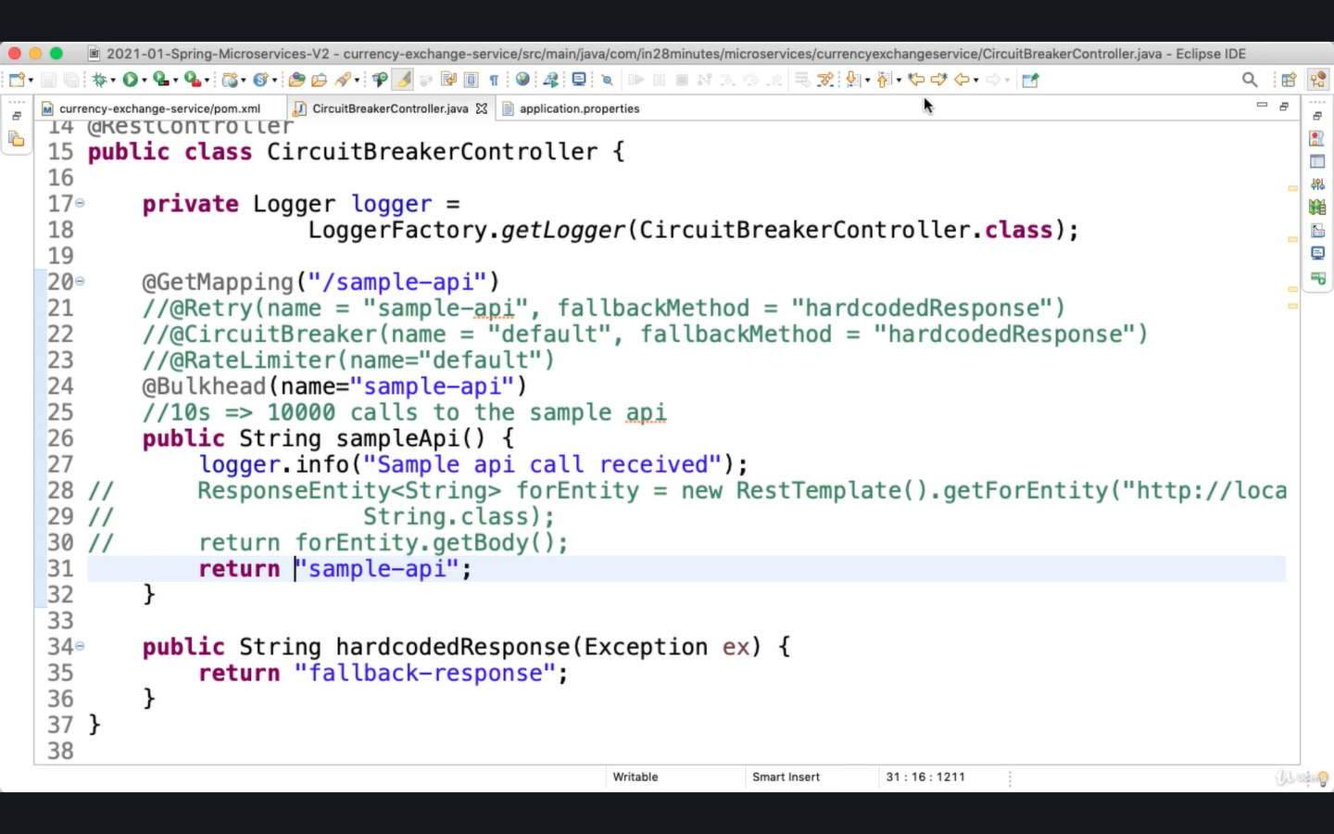

Comment @RateLimiter

Add @Bulkhead(name=sample-api) annotation

To configure bulkhead max concurrent calls go to application.properties and add:

resilience4j.bulkhead.instances.sample-api.maxConcurrentCalls = 10

